Quality Control of Concrete in Less Technically Developed Sites: Cast Study

Hisham Qasrawi
Senior Lecturer, Civil Engineering, Department, The Hashemite University, Zarqa, Jordan

Jamal Qtaishat
Manager of Jordanian Codes and Specification Committee, Ministry of Public Works and Housing, Jordan

Imad Abed-Al-Rahim
cProject Director, King Abdul Azziz International Airport, Bombardier, Saudi Arabi

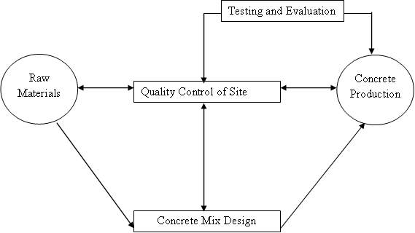
Abstract—The paper summarizes the authors’ experience in quality control and quality management of site concrete in less technically developed sites; such as those prevailing in many local sites. Major problems of quality control of concrete are discussed from a distinct point of view. The problems that were overviewed, are: (1) Lack of genuine specifications and standards, (2) lack of communication between academic institutions and the industry, (3) technology, (4) lack of well-trained and experienced workmanship, (5) lack of supervision, (6) incorrect production practices, (7) lack of testing and evaluation, (8) the role of the consultant and the contractor, and, (9) competition, tendering, costs and benefits.
The authors have provided practical examples and figures showing the results of incorrect application of the procedures encountered during construction. Special tests and plots, obtained from a practical case, in order to control and overcome the problems are introduced. Special solutions and recommendations are suggested to overcome the basic problems using available resources.
Keywords-Concrete, quality control, less developed sites; mix design, construction.

Introduction to Quality Control
Strength, durability and serviceability of concrete depend directly on the quality of concrete produced at sites. No good acceptable concrete can be produced without strict quality control during all production processes.
The basic concepts of concrete quality control can be summarized in the diagrammatic representation shown in Figure (1).
The quality control process starts by selecting raw materials, which must be acceptable for use in concrete. The raw materials include cement, aggregates, water and admixtures or additives.
Once properties of the raw materials are determined, concrete mix proportions are obtained using any acceptable concrete mix design method. Trial mixes are then prepared and tested at the laboratory before final concrete mix proportions are determined. These mix proportions are then tried at site conditions and necessary adjustments are made.

Figure (1): Schematic Representation of the Major Processes of Quality Control

During concrete production, various tests must be performed in order to check the required properties of concrete. The basic tests are workability, air content, density and strength. Changes in materials, mix proportions, production methods or construction practices are made whenever and wherever necessary in order to maintain the required properties and the required degree of quality control. A successful method for concrete quality control of strength is by plotting the moving average of the strength. A behavior similar to figure 2 is expected. In the figure three zones are observed:

Figure (2): Schematic Representation of the Major Processes of Quality Control
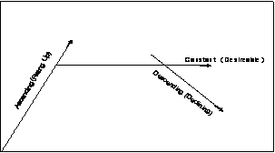
- The ascending period, in which concrete strength increases and this indicates higher values than required and economy may not be attained.
- The constant period which indicates constant quality control. This is the behavior the engineer should aim to.
- The declining period which indicates lower quality control and possibly failure to attain the required quality.

Major Problems of Quality Control in Developing Countries & Less developed sites

Lack of Genuine Specifications and Standards
Many of the developing countries do not have their own genuine standards based on their own experience. Instead they either use some international standards or obtain some standards, which depend directly on some international standards or specifications. The most commonly used standards and specifications in developing countries are ASTM, ACI and the BS. Examples of such use are clear in references (Saudi, Kuwait, Jordanian and Indian specifications (2-6)). In many cases, the international standards do not suit the requirements for certain countries or certain condition. For example, the accepted range of sand grading in ASTM C 33 (7) is quite different from that of the BS 882:1992 (8). Therefore, some sand that is accepted by BS standards and considered quite suitable for concrete work may not be acceptable by ASTM standards. Such difference in standards causes “confusion” among engineers who try to apply international standards in certain conditions where no available local specifications and standards are available. In some other cases, available materials may not totally comply with the international specification being applied; hence the engineer must use “what is available” or import materials such as sand or gravel!
In many cases, local specifications in some developing country refer to more than one international standard. Moreover, different institutions and firms in the same country may adopt different international codes and specifications. Consequently this causes more confusion among engineers.

Lack of communicatio between Academic Institutions and the Industry
This problem is a major problem in developing countries where the engineer is taught certain international specifications and standards during his study and then has to use other specifications during his work. For example, most of the universities in the Arab World teach the ACI 318 in the courses related to the design of reinforced concrete structures while their codes of practice for the design of reinforced concrete is based on other specifications such as BS 8110 and vice versa. In some cases, the student is taught the in-lb system of units and has to use the kg-force or the SI unit systems during work. Hence, the newly graduated engineer faces confusions and problems during his first months of work. Of course, such confusion would be reflected in the design and construction of concrete elements and structures. Also, in developing countries, many engineers are graduates from foreign academic institutions located all over the world. For example, in Jordan in 1999, there was about 39000 registered engineers graduated from various universities located all over the world. Table (1) shows the distribution of engineers with respect to their universities. Of course, unless strict regulations prevail, it is easier for an engineer to use the codes of practice, standards and specifications taught to him during his study. Such practice would result in buildings, which do not comply with the same standards or specifications in design or construction. Therefore, no standard quality of concrete is obtained in structures. For example, recently, Jordan is successfully trying to solve the problem by forcing engineers to follow Jordanian specifications and codes of practice. Any project that does not comply with the Jordanian codes and specifications will not be signed and released for construction. Allowance is given only for the cases where no Jordanian specifications or codes are available.
Table (1): Distribution of Engineers in Jordan With Respect to the Geographical Location of Their Graduation Universities in 1999 (20
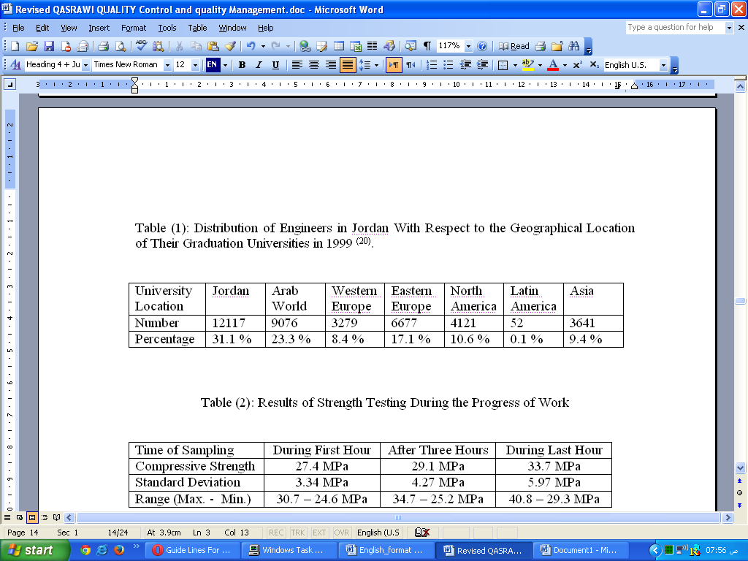

Lack of Technology
In many concrete sites, the usual requirements for concrete production may not be available. Concrete is produced by the “old-fashioned” methods, which mainly include:

- Volume batching of concrete ingredients. This problem is increased when using measuring containers with inconsistent volume. Such practice would (of course) end with variable quality of concrete. The traditional way is that the workers use one sack of cement for a given volume of coarse and fine aggregates. In order to illustrate the severity of the problem, three samples (each consisted of six cubes) were taken from a concrete site as follows:
Sample 1 was taken during the first hour of work.
Sample 2 was taken after three hours of starting work.
Sample 3 was taken during the last hour of casting.
The three samples were supposed to have a compressive strength of 25 MPa. The results obtained are shown in Table (2).
Table (2): Results of Strength Testing During the Progress of Work
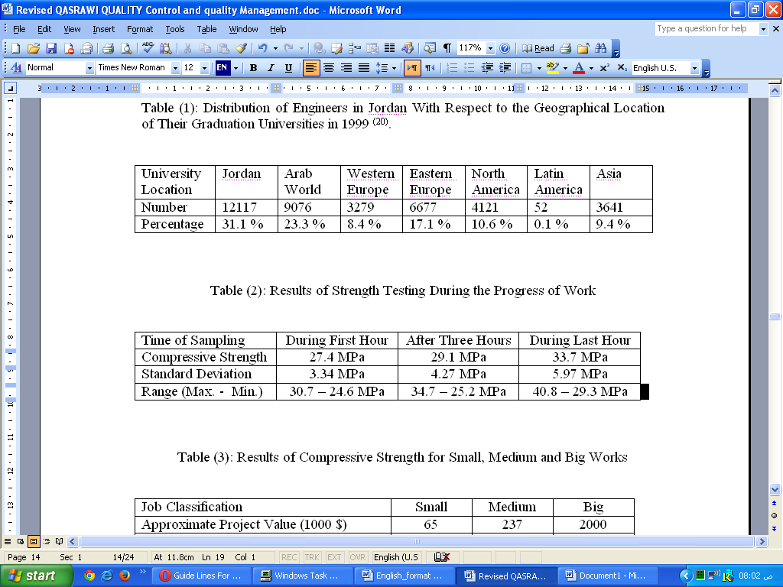

It is clear that the compressive strength of Sample 1 was the lowest while that for Sample 3 was the highest. On the other hand, the standard deviation was the lowest for Sample 1 while it was the highest for Sample 3. It has been observed that the workers are active in the first hour, overfill the measuring containers, carry them and empty them in the mixer. In the last hour, the workers were tired so they partially filled the containers. This resulted in an increase in the cement content of the mix.

- Hand mixing of concrete is used, in some cases, resulting in high variations of concrete quality and homogeneity.

- Transporting mixed concrete by manual methods. The workers usually use “cans” or “hand carriages” to carry, transport and cast concrete in its final place. In many cases, this procedure results in segregation and separation of particles.

- Insufficient compaction of concrete. The workers may use incorrect hand methods of compaction. In some cases, no compaction is applied and the workers “randomly” add extra water to ease the flow of concrete. Such practice would result in bad quality concrete. In some concrete sites, a simple small vibrator may be available but in many cases it does not suit the task. Although concrete mixing in mechanical mixers would be better than hand mixing, batches of concrete would still be nonhomogeneous due to the previously incorrect “old-fashioned” practices in concrete production.

Lack of Well-Trained and Experienced Workmanship
In many cases, problems arise from the following:

- Inexperienced workmen are assigned to watch and judge the mixing process and the suitability of the resulting mixes for concreting.

- Inexperienced workmen who are assigned to perform compaction of concrete. In many cases, workmen do not follow the correct procedures described in standards and specifications. Many references summarize the correct and incorrect procedures and the possible consequences (9, 10, 11). One of the most common incorrect procedures is casting concrete columns by dropping concrete for the full height of the column.

- Poorly trained technicians or workmen are allowed to prepare specimens at site. This may result in incorrect strength results and the consequent misjudgment that follow.
.

Lack of Supervision
In small size jobs, there is usually no supervision, while in medium size jobs there is only intermittent supervision. Continuous supervision is available only in big size jobs. A study by the Association of Engineers on small jobs (housing units) where sudden site visits were carried out revealed that more than 80 % of the visited sites lacked the presence the engineers representing the contractor or the consultant (26). Therefore, bad quality is observed in the first two cases. Table (3) summarizes the results obtained from small, medium and big jobs.
Table (3): Results of Compressive Strength for Various Works
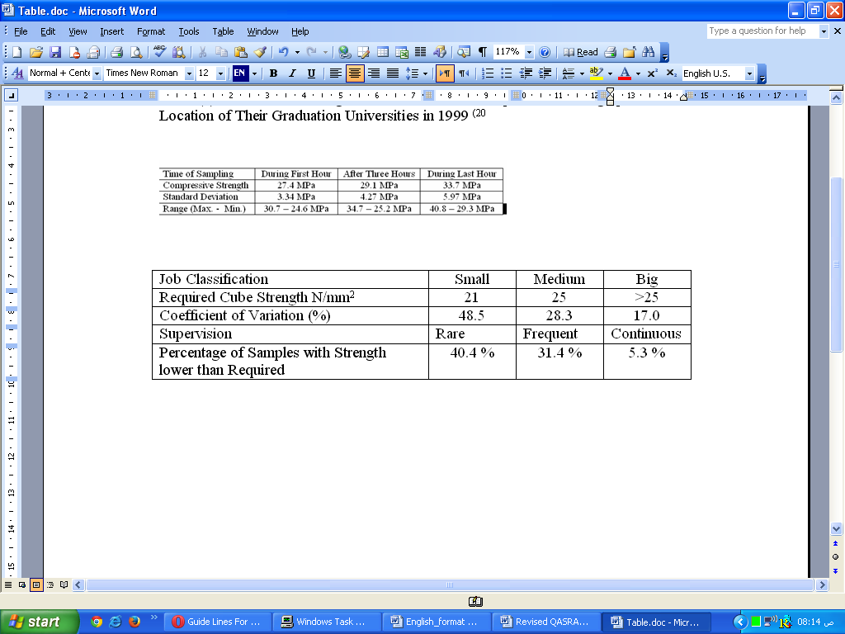

Incorrect Production Practices
- Batching: Volume batching is the main method prevailing in preparing the quantities of ingredients for concrete at site.
- Mixing: Hand mixing and the use of small mixers are the dominant methods in concrete production.
- Casting: Incorrect procedures are followed such as placing concrete freely from heights exceeding 1.5 meters. In casting columns, the free height, sometimes, exceeds six meters.
- Compacting: In many cases concrete is not compacted properly. Sometimes, concrete is even left without any compaction.
- Curing: The problems of curing include one or more of the following:
- No curing is used after finishing and formwork removal.
- Incorrect curing method may be chosen. For example, sprinkling concrete with water may be applied in hot weather for only once or twice a day.
- Insufficient curing period.
- Formwork Removal: The contractor usually strips formwork earlier than recommended by specifications in order to reuse formwork as quick as possible.

Lack of Testing and Evaluation
Engineers tend to take the least amount of specimens in order to evaluate concrete. Many engineers tend to consider that once concrete has attained its characteristic strength it is the end of quality control, forgetting that they must also attain a certain acceptable standard deviation or coefficient of variation in order to attain the desirable degree of quality control. Concrete density and air content are seldom measured.

The Role of the Consultant and the Contractor
No single project can be successfully completed with the desirable quality without full cooperation between the contractor and the consultant. The contractor should be keen to fulfill the tasks without deviating from codes and specifications.
On the other hand, the consultant should use his “power” to make sure that the contractor has provided all possible means necessary to attain the required quality. The main role of the consultant is, therefore,
- to supervise and check the items before starting and after completion of work,
- to use the right men and the right number, and,
- to monitor and comply with every item with specifications.

In developing countries, the major problems are:
- Ambiguity in codes, standards and specifications.
- Improper relationship, improper understanding and lack of communication between the contractor and the consultant. The contractor looks upon the consultant as if he were his “enemy” trying to deprive him from profit.
- Lack of communication between sites and main office may result in improper decisions without consulting the experts.
- Wrong men in the right places and right men in the wrong places. Sometimes, even wrong men in the wrong places may be found.
- Lack of staff of both the consultant and the contractor.
- Low wages, which may delay work and affect quality.
- Instability of jobs and large number of unemployed persons cause “anger" among employees and thus improper decisions.

It is well known that the consultant and the contractor should work as one team in order to produce concrete with the required quality. Unfortunately, in many cases, they do not communicate adequetly: The contractor looks upon the consultant as the one who is trying to reduce his margin of profits. Hence, he tries to collect money in any decent or indecent way. By such behavior, the consultant takes advantage of any slight mistake that is made by the contractor. Therefore, instead of working as one team, both the contractor and the consultant work as enemies in the site resulting in bad quality of concrete.
Another problem observed at site is the full or partial absence of the consultant in small and medium work jobs leaving the contractor to work alone. The consultant, himself is busy in other projects. This, of course, casts doubts on the produced concrete.

Competition, Tendering, Costs and Benefits
This title is one of the main problems, which may result in loss of quality of concrete in developing countries. Before pricing, the contractor should carefully study
(a) the client’s requirements, (b) the possible effects of site and the surrounding area, (c) project documents and specifications, (d) available resources, money, men and equipment, (e) market and contract conditions, (f) design economics, (g) possible variation factors, (h) external works (preparatory and final), (i) engineering services,(j) quality considerations, (k) risk, (l) legal aspects, (m) insurance, (n) time, (o) buildability, (p) constructional details, (q) substructure and superstructure, and, (r) construction methods.

Based on proper analysis, the contractor should be able to estimate the costs of projects and then add his own profit.
In developing countries, competition is high, and therefore, contractors try to “survive” pricing close to the actual costs of the project. Hence, they cannot obtain a marginal profit without “forgetting” some of the costly or slow items in the specifications. Such behavior would, of course, be reflected in the quality of the structure.
Furthermore, when compared to firms in developed countries, most of the firms in developing countries are considered “small” with relatively low capital money. Therefore, in large projects that require high amounts of funds, these small firms cannot compete with those larger firms from developed countries. Hence, no opportunity is left for the small firms without the intrusion of “partnership” with other firms. Hence, huge parts of the profits will go to other international firms instead of being distributed among national local firms. Therefore, small firms will not survive. On the other hand, this partnership may be necessary in some projects which require special experience and special technology.
In developing countries, so many small contracting and consulting firms are licensed. Many of these firms depend mainly on everyday profit. Therefore, they try to get the contract by any available mean. In many cases, the following are observed:
The margin of profit is usually small. This observation leads to the following:
- The contractor does his best to collect money even when deviating from specifications.
- Less qualified and experienced staff from both the contractor and the consultant are assigned in order to save few dollars.
- Absence of the project leaders, such as the project manager, from both the contractor and the consultant because they are assigned to work in more than one project.
The budget may be small and the contractor has to accept a small margin of profit. This is observed in countries, which gets some external source of limited loans for their projec.

Basic Testing For Concrete
In order to attain and maintain concrete quality during concrete production, frequent site tests should be performed. For any concrete, tests should, at least include workability, density, air content and strength.

Workability:
Slump test is normally the sole test used at site for normal concrete. Although it does not give a good indication of workability, it is simple, quick and its results can be easily correlated to other tests (10, 11). It is important that concrete producing shear slump should be rejected.
However, using the requirements of BS 5328 (13), the following are obtained: (Slump according to BS 1881: Part 102 (14):
- Slump obtained from standard sample should be ± 25 mm or ± ¹/₃ the specified value whichever is greater.
- Slump obtained from truck discharged sample should be as follows:
  - +35 mm to – 25 mm for slump of about 30 mm.
  - ± 35 mm for about 50 mm slump.
  - ± ¹/₃ the specified value for slumps exceeding 80 mm.

Based on practical experience in local sites the authors recommend Table (4) for developing countries. Slump values in the table are according to ASTM C143 (15).
Table (4): Compliance Requirements for Workability of Fresh Concrete (Author)
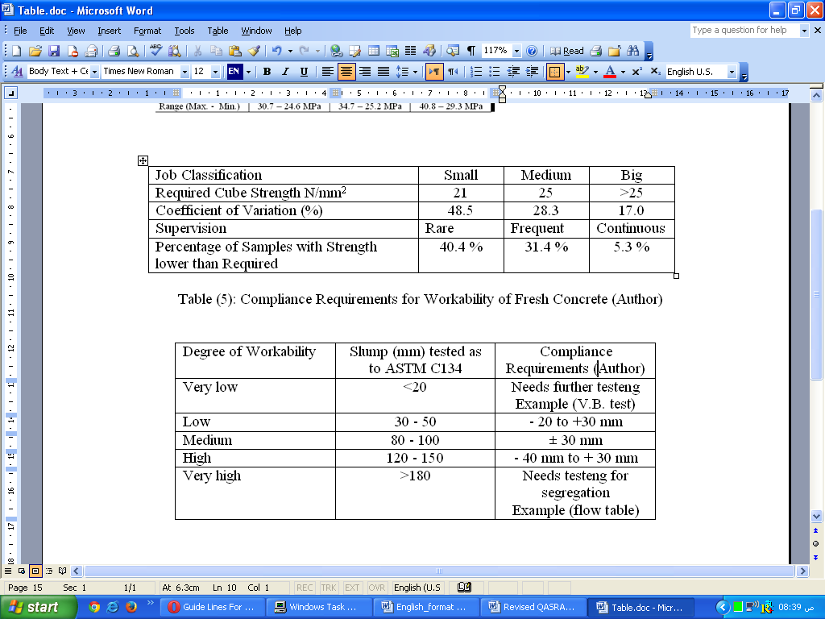

Fresh Concrete Density:
The density of fresh concrete should be measured frequently and compared with the value obtained from final mix design. Based on practical experience in local sites, quality control is considered acceptable if the fresh density of concrete is within ± 2.5 % for ready mixed concrete and ± 3.5 % for cast on-place concrete.

Hardened Concrete Density:
The density of hardened concrete should be measured frequently, before crushing the specimens. In order to maintain homogeneity of results, the density should be based on saturated surface dry samples. Based on practical experience at local sites, quality control is considered “good” if the hardened density of concrete is within ± 4 % of the average measured density for ready mixed concrete and ± 6 % of the average measured density for concrete mixed in-situ.

Air content:
Air content in fresh concrete should be measured frequently in order to adjust its amount in air-entrained concrete, or to control mix proportions in non air-entrained concrete. Based on practical experience in local sites, in normal concrete, good quality is attained when the values obtained are ± 1 % of the expected value. In air-entrained concrete, good quality is attained when the values obtained are ± 1% apart of the specified value.

Strength:
Strength is the most important property for structural concrete. Therefore, concrete should be tested for strength at the specified age. Because of its variability, especially in developing countries where many concreting problems are present, not less than three specimens must be tested each time. Moreover, it is advised that more than three samples are prepared and tested in order to cope for the expected higher variations. In order to maintain and control quality of concrete produced at site, results should be carefully analyzed and special charts should be plotted and controlled. Each time strength samples are crushed, the engineer should report the following:
- The individual strength of each tested cube.
- The average of each tested group.
- The moving average of the tested cubes.
- The standard deviation at each stage of the project.

Application of the Method in a Case Study
Quality control assurance calculations that appear in the literature may be tedious and troublesome for the site engineer (16, 17, 18, 19). However, these special calculations are necessary for quality control. These calculations can be simplified in the following approximate method:
- Plot the individual strength of the tested samples in a plot similar to that shown in Figure (2). The results are shown in Figure (5). The individual strength is the average of three cubes taken from the same sample. However, according to ACI 214 (17), at least two strength results are needed.
- Plot the moving average in a way similar to that shown in Figure (5).
- Plot the moving standard deviation of the tested samples in a way similar to that shown in Figure (6).

As an example on the application of the method practically, the method was applied in Murhib Water Project, where the first author was assigned as a quality control engineer. The project consisted of two medium reinforced concrete water tanks, two pumping stations offices, retaining walls and external work. The structural required strength was 25MPa. The mix was designed according to the British DoE mix design method (5% values are allowed to fail). The mix requirements are shown in Table 5. Results are shown in Figures (4-6).
Table (5): Mix Requirements
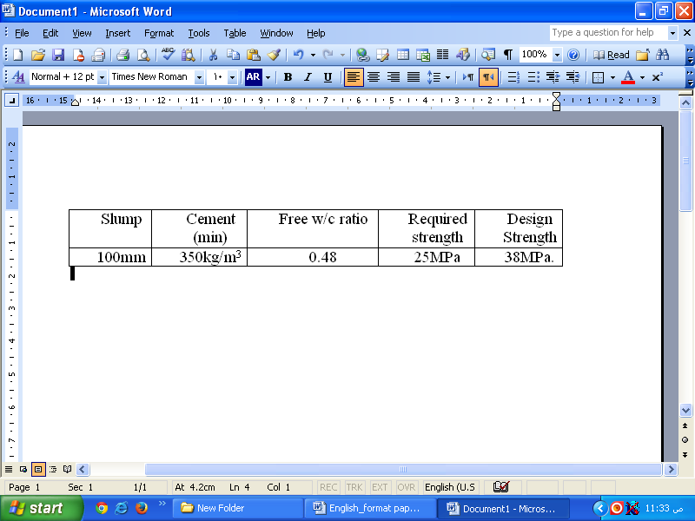

At any stage of the project, calculations can be made and the quality regarding the strength of concrete control can be assessed using Figure 2 and Tables (6) and (7). In developing countries, Table (6), which is based on local site experience can be used to assess the quality control of ready mixed concrete or concrete cast using batch plants and very good site conditions. Also, Table (7), which is also based on local site experience, can be used to assess the quality control of concrete mixed at site. It is worth notifying that the values presented in Tables 7 and 8 are applicable for normal strength concrete having a 28-day cube compressive strength of 25 to 40 MPa.
Figure (4): Individual Cube Strength

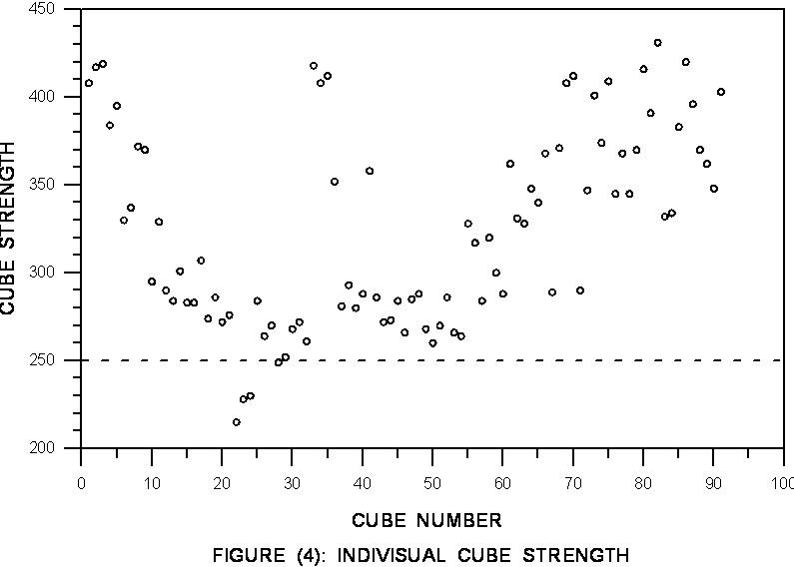

Figure (5): Moving Average Cube Strength
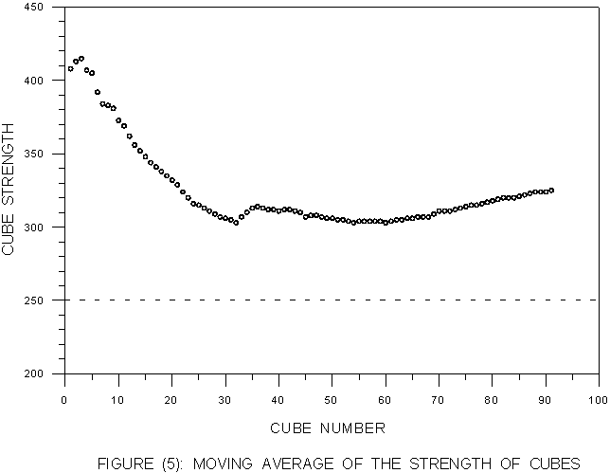

Figure (6): Moving Standard Deviation of Cube Strength

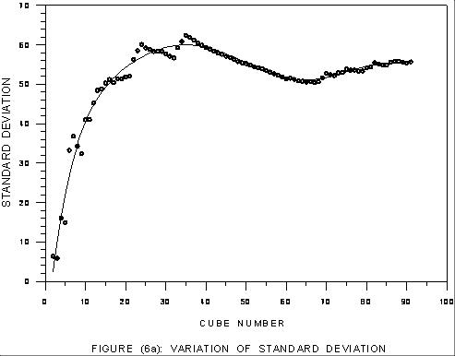

Table (6): Suggested Degree of Quality Control as Assessed from Standard Deviation (Ready Mixed Concrete and Batch Plant Concrete)
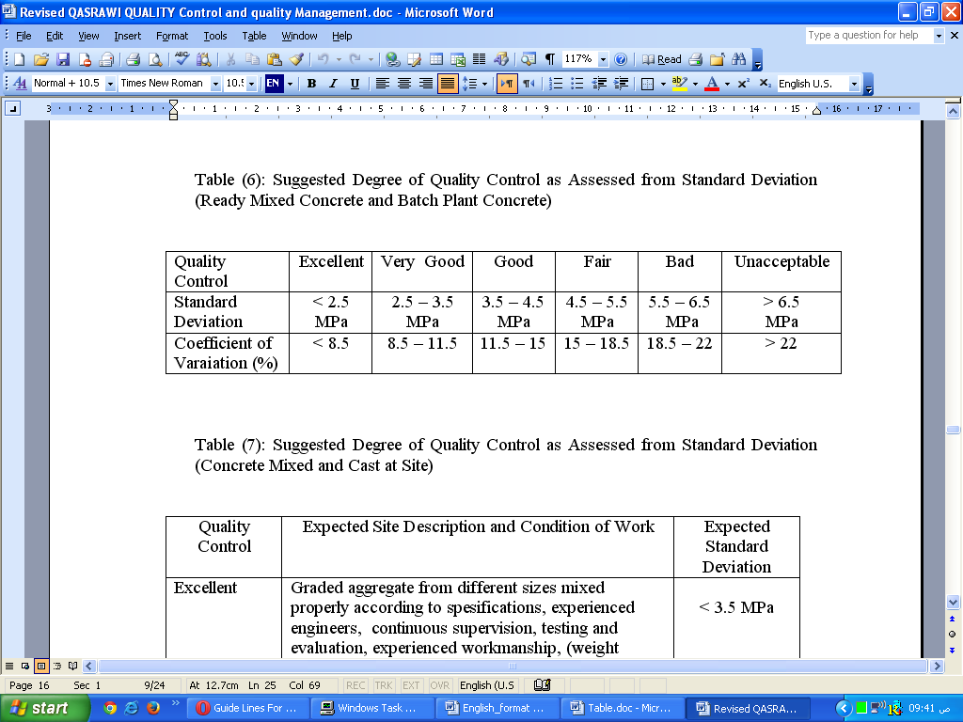

Table (7): Suggested Degree of Quality Control as Assessed from Standard Deviation (Concrete Mixed and Cast at Site)
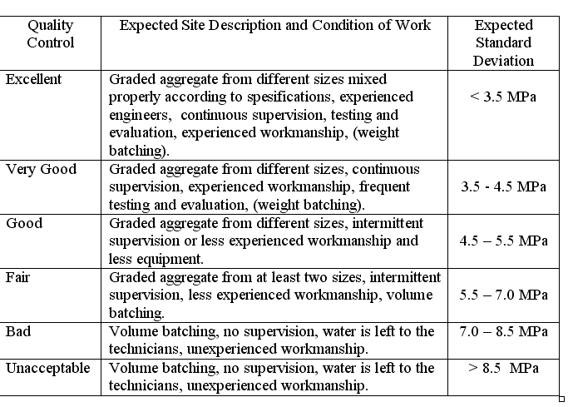

According to ACI 214 (17), the standard deviation remains more nearly constant particularly at strengths over 3000 psi (≈21 MPa); but for the within-test variations, the coefficient of variation is considered to be more applicable. For the sake of comparison, ACI 214 limitations are shown in Table (8), taken from ACI 214 Table 3.5, for the sake of comparison.

Table (8): Standards of Concrete Control According to ACI 214
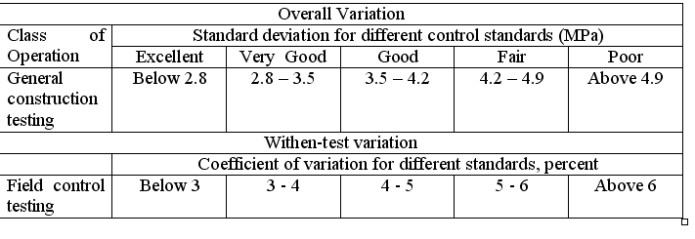

Discussion of the Results
From figure 5 it can be seen that most the cubes exceeded the required limit (25MPa). The results starts by values approaching (or even exceeding) the required value of the mix design (38MPa). One of the reasons for this is the use of 0.45 w/c ratio instead of the 0.48. This indicates high quality control at the start of the project. However, the strength started declining after few tests and when Figure (50 was plotted, the behavior was similar to the "declining" in Figure 2. Unfortunately, this was caused by the lack of comprehensive overall quality control by the contractor. Alarms (in this region) are clear in Figure 6, where the standard deviation is increasing and the probability of failure reached about 30% instead of the assumed 5%. The inevitable occurred and the mix failed to attain the required strength. The contractor increase strict supervision and followed the suggested measures ending with values higher than required. Later, the results showed the desirable constant behavior in the moving average. The final standard deviation was 4.80 MPa indicating a fair quality control. At this stage, the mix design can be adjusted with lower values of the standard deviation and hence better economy in mix design. Practically, this was not done because regulations in Jordan do not allow such change on the "legalized mix design" at the start of the project.

Summery and Conclusions
The study shows that the engineer can attain the required quality without any special tests or techniques. Simple tests such as slump, air content and density, combined with the use of the tables provided in this study can provide good control on fresh concrete. Simple plotting of the cube results (individual strength values, moving average and moving standard deviation) gives good idea about the quality control of the mix during the process of construction. Remedial measures can be applied when and where necessary.
The use of the tables and charts described and given in this research can give good ideas about the procedures that are followed in the site.

References
- H. Qasrawi, “Quality control of site concrete”, Civil Engineering Journal, Association of Engineers, Jordan, December (1994), pp 1 –3.
- Specification Committee, Ministry of Public Works and Housing, Saudi Arabia “General Specifications for Building Execution, 1st. Edition, Saudi Arabia, 1982.
- H. Qasrawi and Committee, General Specifications for Building and Engineering Works, State of Kuwait, 1st. Edition, 1990.
- Specification Committee, Ministry of Public Works and Housing, Jordan General Specifications for Buildings: Volume 1: Civil and Architectural Works Ministry of Public Works and Housing, Jordan, 1st. Edition, 1985.
- V. Vazirani and M. Ratwani, Concrete Structures, 8th. Edition, Khanna Publishers, India, 1978.
- S. Ramamrutham, Design of Reinforced Concrete Structures, 8th. Edition, Dhanpat Rai and Sons, India, 1978.
- ASTM C 33 – 93, Specifications for concrete aggregates, ASTM, USA, 1993.
- BS 882: 1992, Specifications for aggregates from natural sources, BSI, UK 1992.
- S. Kosmatka and W. Panarese, Design and Control of Concrete Mixtures, 13th. Edition, PCA, USA, 1988.
- A.M Neville., Properties of Concrete, 4th. Edition, Longman, London, 1995.
- A.M. Neville and J.J. Brooks, Concrete Technology, Longman, UK, 2010.
- A. Ashworth, Cost Studies of Buildings, 2nd. Edition, Longman, 1995.
- BS 5328: Part 1: 1991, Part 2: 1990, Part 3: 1990 and Part 4: 1990. BSI, UK.
- BS 1881: Part 102: 1983, Method for determination of slump, BSI, UK.
- ASTM C143 – 90a, Test for slump of hydraulic cement, ASTM, USA, 2000.
- L. Taerwe and H.Lambotte, Editors, Quality control of concrete structures, Proceeedings of the Second International RILEM Symposium, RILEM, E & FN SPON, UK, 1991.
- ACI SP-46, Proportioning Concrete Mixes, ACI, USA, 1975.
- N. Jackson and Dhair , Civil Engineering Materials, 4th edition, McMillan Press LTD, 1993.
- ACI Committee 214 - 02, “Evaluation of strength test results of Concrete”, ACI Manual of Concrete Practice, ACI, USA, (2005).
- H. Bishtawi, A Survey of Engineering qualifications and expertise, Engineers, No. 32, , Association of Engineers, Jordan, (1999), pp 15 – 19.
- H. Y. Qasrawi, and M. Abu-Afeefeh, Quality control of concrete in developing countries”, Proceedings of the Second Conference for Construction Materials and Economical Challenges, Cairo, Egypt 2000.
- H. Qasrawi, Concrete Compaction in Jordan: Problems and Solutions, J. J. of Applied Sciences, Vol. 2, No 4., (2000) pp 1 - 21.
- ACI 309R–96, Guide for consolidation of concrete, ACI Manual of Concrete Practice, ACI, USA, 2012.
- ACI 309.2R–98, Identification and control of visible effect of consolidation in formed concrete, ACI Manual of Concrete Practice, ACI, USA. 2012.
- ACI 309.3R, Guide for consolidation of concrete in congested areas, ACI Manual of Concrete Practice, ACI, USA. 2012.
- Cement Committee - JAE, Quality Control of Small Projects, Report for Cement Factory, Jordan Association of Engineers, Jordan, 2003.
- ACI 211.1-91, Reapprovred in 1997, Standard practice for selecting proportions of normal, heavyweight and mass concrete, ACI Manual of Concrete Practice, ACI, USA. 2012.

