Investigating the Effect of Super Absorbent Polymer on the Performance of Plain Concrete

Moayyad Al-Nasra
Civil Engineering Department
Applied Science University
Amman, Jordan

Mohammad Daoud
Department of Civil Engineering,
Zarqa University,
Zarqa, Jordan

Abstract-- The super absorbent polymer (SAP) has the ability to absorb relatively large amount of water and convert it into gel at the same time the volume increases proportionally. These properties are found to be very useful and effective in plain concrete. Also the use of super absorbent polymer in concrete is proven to have many positive effects on the properties of concrete in its both stages; fresh concrete and hardened concrete. This study focuses on the water tightness properties of plain concrete with time. The study includes short term and long term effect of the super absorbent polymer on the water sealing properties. There are also many advantages of the use of the super absorbent polymer in plain concrete including providing internal water source. This internal water source acts as internal curing agent after the final setting of concrete. At the same time the SAP releases water at relatively slower rate at the fresh concrete stage. The SAP also provides additional voids in the concrete mass. These voids affect the concrete strength negatively at the same time improve the concrete performance by improving the concrete workability and placeability, reducing the concrete susceptibility to freezing thawing cycle, and improving concrete stability.
Keywords – Concrete Curing; Concrete Strength; Sealant; Super Absorbent Polymer; Water Tightness
I. INTRODUCTION
The SAP absorbs water and converts it into gel, then releases it slowly with time, at the same time the gel volume increases proportionally. This property is very useful when it comes to watering plants over time. The expansion in volume has the tendency to clog the water pathways in the concrete mass, and consequently improving its water tightness properties. The use of SAP is proven to be very effective as a sealant in plain concrete if sufficient amount is used. This study focuses on the long term effect as well as the short term effect of the use of the SAP in plain concrete. Several samples were prepared with different SAP content. The content of SAP is measured as a percentage of the Portland cement used by weight. The amount of water added to the fresh concrete is one of the most important key factors that affect the concrete properties, including water tightness durability and strength. The water is an essential ingredient needed for the hydration process in the fresh concrete and for the curing process in the hardened concrete at its early stages. Excessive amount of water added in the fresh concrete improves the concrete workability in general, reduces the concrete strength, and increases the drying shrinkage of the hardened concrete. Different admixtures were used to reduce the amount of water demand in the fresh concrete without jeopardizing the workability. Water reducer admixtures were used extensively in the ready mix plants. The most common admixture used nowadays is the superplasticier which is water reducer and at the same time retarder. The water gel created in the fresh concrete by the use of SAP provides cushioning and lubrication in the concrete mass which in turn improves the concrete workability as well as concrete stability.
Jensen (2013) used superabsorbent polymers in concrete. His study focused on the strength and shrinkage of concrete. He concluded that the shrinkage of concrete due to loss of water to the surroundings is the cause of cracking both in the plastic and in the hardened stage. This type of cracking can effectively mitigated by slowing down the water loss. The superabsorbent polymers use in concrete has the potential to reduce concrete cracking. Jensen and Hensen (2001) studied the autogenous shrinkage phenomena in concrete. They concluded that the autogenous shrinkage may lead to cracking and affect concrete strength and durability, which is also, can be considered as technological challenge of high performance concrete. Addition of superabsorbent polymer in the ultra-high-performance concrete can be used to control the autogenous shrinkage. They also conducted tests that show that the shrinkage reduction due to superabsorbent polymer is related to a corresponding increase in the internal relative humidity of the cement paste. In addition, the use of superabsorbent polymer in concrete resulted in a reduction or elimination of stress buildup and related cracking during restrained hardening of these high-performance cementitious systems (Jensen and Hensen 2002).
Al-Nasra (2013) studied the use of Sodium Polyacrylates as SAP in concrete. His study focused on determining the optimum amount of SAP to be added to the concrete in order to maximize the strength and durability of concrete. Al-Nasra concluded in his study that the optimum amount of SAP is 0.11 percent of cement by weight, which he showed to be the most effective amount to be used in concrete.
The use of superabsorbent polymer in concrete is also useful in frequent freeing-thawing cycle environment, by providing the concrete frost protection. The superabsorbent polymers particles shrinks during the hydration process leaving voids in the concrete similar to the voids created by adding air entrainment agent to the concrete. The air bubbles left in the concrete are critical to absorb the hydraulic pressure due the water freezing. Water expands upon freezing about ten percent in volume generating hydraulic pressure in the concrete that has the potential to cause the concrete to crack. Providing voids in the concrete absorb the hydraulic pressure and provide addition space for the water to expand. The same can be said about the osmotic pressure in the concrete. The osmotic pressure is usually generated due to the difference in salt concentration in the water. This difference in salt concentration can be created by adding deicer to the concrete top surface, for the purpose of melting the ice on the concrete. Also these voids can be useful to absorb other kinds of internal pressures in concrete including alkali reactivity pressure.
Snoeck et al (2012) studied the use of superabsorbent polymers as a crack sealing and crack healing mechanism in cementitious materials. Their research focused on the use of the superabsorbent polymer to seal concrete cracks. As concrete cracks due to its low tensile strength and as harmful unfriendly chemicals may migrate into these cracks, the durability of concrete is endangered if no proper treatment or manual repair is applied. The first stage focused on hindering the fluid flow by swelling of superabsorbent polymers after they are exposed to a humid environment. The sealing capacity was measured by means of water permeability tests and through visualization of permeability tests by neutron radiography. They also concluded that the use of superabsorbent polymers is able to seal cracks and thus allow a recovery in water-tightness as a decrease in permeability is noticed. The second stage focused on healing of small cracks by the use of fiber reinforced cementitious materials that have the ability to restore the mechanical properties. These mechanical properties were analyzed by four-point-bending tests and the crack closure was microscopically monitored. Cracks close through the combination of further hydration of unhydrated cement particles, precipitation of calcium carbonate and activation of the pozzolanic reaction of fly ash. Also they concluded that the desorption of superabsorbent polymers triggers healing in the vicinity of crack faces and cracks up to 130 μm were able to close completely in wet/dry cycles due to the precipitation of calcium carbonate.
The process of curing involves maintaining satisfactory moisture content and temperature after concrete is placed in order to hydrate the cement particles and produce the desired hardened concrete properties. Proper curing can improve strength, durability, abrasion resistance, resistance to freeze-thaw cycles, deicer scaling resistance and reduce concrete shrinkage. Traditionally, concrete has been cured externally either through the use of water curing or sealed curing. Curing either supplies additional moisture from the original mixing water or minimizes moisture loss from the concrete. Water may be bonded directly on the concrete surface or may use other methods like wet burlap bags or fogging near the surface of the concrete to prevent evaporation of water from the fresh concrete. Sealed curing is accomplished by applying some sort of sealant to the surface of concrete in order to prevent moisture loss. Internal curing can be divided into two categories. The first category is internal water curing in which an internal curing agent stores water during mixing which is gradually released as hydration processes. The second category is internal sealing which is very similar to external sealed curing in that its goal is to prevent the loss of moisture from the concrete (RILEM, 2007).
II. SUPER ABSORBENT POLYMNER
The super absorbent polymer used in this study is Sodium Polyacrylate, also known as water-lock, which is a sodium salt of polyacrylic acid with the chemical formula [-CH₂-CH(COONa)-]_{n} and broad application in consumer products. It has the ability to absorb as much as 200 to 300 times its mass in water. Sodium polyacrylate is anionic polyelectrolytes with negatively charged carboxylic groups in the main chain. Figure 1, shows the composition of the sodium polyacrylate.

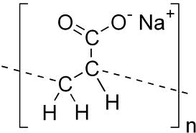
Figure 1: Sodium Polyacrylate chemical compound.
Sodium polyacrylate is a chemical polymer that is widely used in a variety of consumer products for its ability to absorb several hundred times its mass in water. Sodium polyacrylate is made up of multiple chains of acrylate compounds that possess a positive anionic charge, which attracts water-based molecules to combine with it, making sodium polyacrylate a super-absorbent compound. Sodium polyacrylate is used extensively in the agricultural industry and is infused in the soil of many potted plants to help them retain moisture, behaving as a type of water reservoir. Florists commonly use sodium polyacrylate to help keep flowers fresh.
III. WATER FLOW TEST
The use of SAP in plain concrete alters several properties of concrete. There is an optimum amount of SAP that can be added to the plain concrete in order to improve its strength, and durability. In the other hand, adding more of SAP in the plain concrete improves the water tightness property of concrete. Also it is relevant to mention that the concrete plasticity improves with the increase amount of SAP in plain concrete. The color and texture of the concrete mixed with SAP will change too. The shiny water surface of the fresh concrete seemed to disappear when using the SAP due to transforming the excess water in fresh concrete into gel.
Several samples were prepared with different amount of SAP added to the plain concrete expressed in terms of percentage of the Portland cement by weight. Table 1 shows the mix design of the three samples used in this study. The samples are labeled as P for plain concrete sample with no SAP added to the mix, S1 sample has 0.2% of SAP, and S2 sample has 0.5% of SAP by weight of Portland cement. The water cement ratio (W/C) is kept constant for all samples used.

TABLE 1: INGREDIENTS USED
Sample  ID | Sand  (gm) | Cement  (gm) | SAP  (gm) | W/C
P | 200 | 100 | 0.0 | 0.45
S1 | 200 | 100 | 0.2 | 0.45
S2 | 200 | 100 | 0.5 | 0.45

Figure 2 shows the dimension of the samples used in this study. Special mold is used to make the test samples. The samples are of cylindrical shape of 35 mm base diameter and 10 mm height. Figure 3 shows a typical sample ready to be tested. A sealant is applied at the perimeter of the concrete samples in order to prevent any leak, and force the water to go through only the concrete sample under pressure.
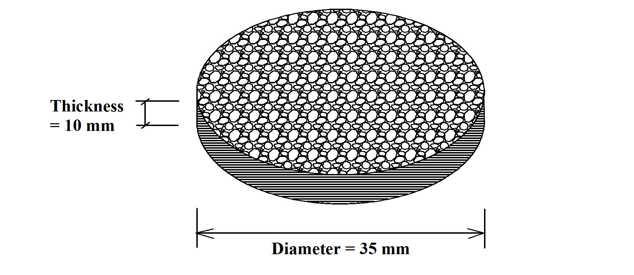
Figure 2: Size of samples used.

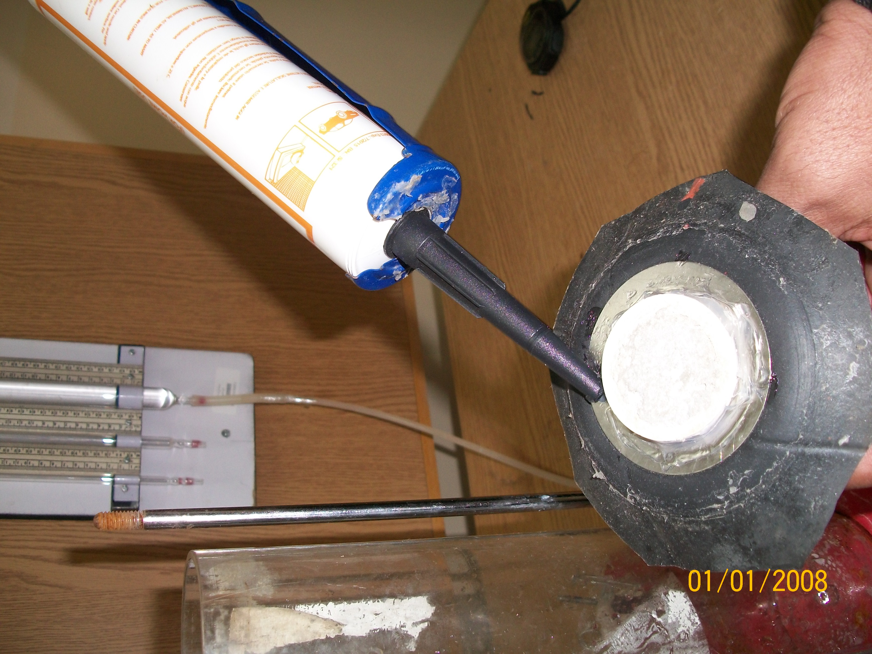
Sample
Figure 3: Preparing samples for the test.
The samples are subjected to a water pressure that varied from 180 cm of water to 170 cm. The average water pressure is 175 cm. The time it takes for the water pressure to drop from 180 cm to 170 cm is measured and recorded. The amount of water that flows through the samples will be constant of about 31 cm³ during the drop of the water pressure by 10 cm. The discharge though the sample can be calculated using the following formula:

Q=V/t (1)
Where;
Q= water flow rate in cm³/min
V= volume of water passing through the sample in cm³
t = the measured time that takes the pressure to drop from 180 cm to 170 cm, discharging a total of about 31 cm³ of water. Thus
The water flow rate = 31.42 cm³/ the measured time (min)
Figure 4 shows the experimental set up. The samples are confined in a chamber and tight sealed at the perimeter.
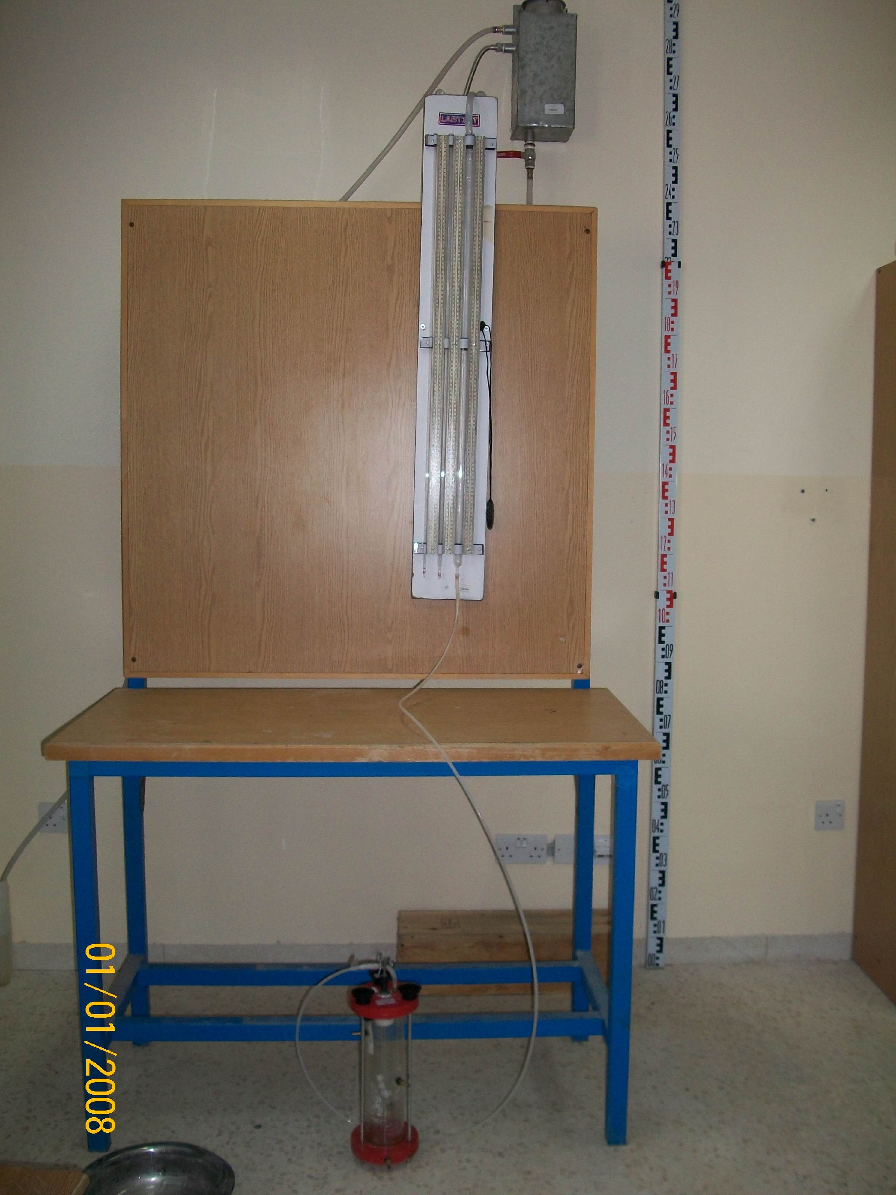
Confined sample
Figure 4: Test set up.

IV. TEST RESULTS
The samples were tested under an average water pressure of 175 cm. The time it took for the water to flow through the concrete layer is recorded at a total of 31.42 cm³ of water flow. The test continued for several days and weeks. Figure 5 shows the flow rates of the three samples tested. This figure shows the flow rate results for a short term duration of 2 hours or less. As can be seen in Fig. 5 that the flow rate decreases with time for the samples prepared with SAP, while the plain concrete sample has the tendency to stabilize at a constant rate of flow.
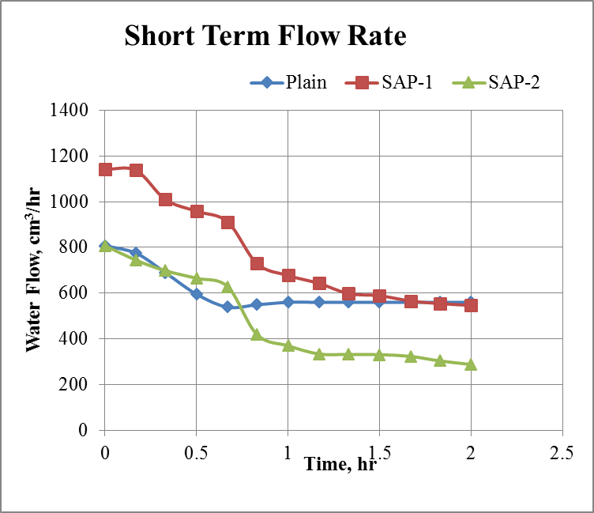
Figure 5: Short term flow rate measurements.
The results obtained for the short term flow study lead to the conclusion that the flow rate is related to the time. Long term study was conducted to focus on the effect of time on the flow rate. Figure 6 shows the results of the long term results. Figure 6 shows that the plain concrete sample has constant flow rate and that the flow rate is not affect by the time. The other samples showed a different trend. The flow rate decreases substantially with time, making it easier to seal the concrete with time. Also one may observe that the increase in the amount of SAP used decreases the flow rate. This long term study is also conducted at the same conditions of the short term study.

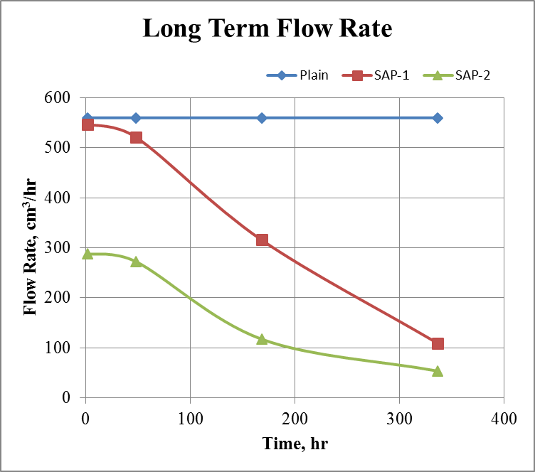
Figure 6: Long term study of water flow rate

V. CONCLUSION
The use of sodium polyacrylate as super absorbent polymer in concrete has promising potential to improve several properties of concrete including the water tightness. This property is very useful to prevent water leaks through the concrete mass making it a self-sealing concrete. This property improves with time if subjected to moisture for a properly designed concrete with adequate amount of SAP. The adequate amount of SAP to be used to prevent future water leak though the concrete mass is yet to be determined. Also the water pressure is another factor that plays a significant role in the water flow rate calculation. The increase in the water pressure increases the flow rate. Also the increase in the amount of SAP used in the concrete mix decreases the flow rate. Several other properties of concrete can be altered by using SAP as an admixture which in turn converts the liquid water into gel.

REFERENCES
[1] Jensen, M, “Use of superabsorbent polymers in concrete,” Concrete International, Vol. 35, No. 1, January 1, 2013, pages 48-52.
[2] Jensen, O., and Hensen, “Autogenous deformation and RH-Change in prospective,” Cement and Concrete Research, Vol. 31, No. 12, Dec. 2001, pages 1859-1865.
[3] Jensen, O., and Hensen, “Water-Entrained cement-based materials: Experimental observations,” Cement and Concrete Research, Vol. 32, No. 6, June 2002, pages 973-978.
[4] Al-Nasra, Moayyad, “Optimizing the Use of Sodium Polyacrylate in Plain Concrete,” International Journal of Engineering Research and Applications (IJERA) ISSN: 2248-9622 www.ijera.com, Vol. 3, Issue 3, May-Jun 2013, pages 1058-1062.
[5] Snoeck, Didier, Van Tittelboom, Kim, De Belie, Nele, Steuperaert, Stijin and Peter Dubruel, Peter, “The use of superabsorbent polymers as a crack sealing and crack healing mechanism in cementitious materials,” 3rd International conference on Concrete Repair, Rehabilitation and Retrofitting (ICCRRR -2012), Cape Town, South Africa, pages 152 – 157, ISBN:9780415899529.
[6] RILEM. Internal Curing of Concrete - State-of-the-Art Report of RILEM Technical Committee 196-ICC. State of the Art Report, RILEM Publications SARL, 2007.

