Underpinning of Existing Structure Using Jet Grouting (case study)
By
Mohammad T. Alsayyed Ahmad, Ph.D., P. E.
International Center for Geotechnical & Engineering Studies
Palestine
Abumoath2@yahoo.com

INTRODUCTION
Many of the structures problems occur due to weakness of soil supporting them. If the structure was designed carefully in terms of elements sizes and reinforcement, then any problem that may appear in the structure can be related to settlement, differential settlement or bearing capacity deficiency. Conventional methods which include excavation and jacketing of the foundations are sometimes adopted to underpin the structures in order to stop the settlement and increase the bearing capacity. Sometimes these methods stand short due to circumstances related to the site. Accessibility to the foundations and to the soil need to be strengthened is important and risk of failures is a concern.
In this paper, a description of a case where differential settlement took place a year after completion of the construction of a stadium in Florida, USA. The settlement occurred before any significant live loading took place. Investigation was made to find the reason behind this settlement and to how to strengthen soil layer/s in order to solve the settlement problem.
The problem was defined as follows: The site was mainly composed of very soft organic soil. The designer elected to use soil replacement in order to adopt shallow foundations; isolated and strip. During soil replacement, in part of the site, the excavation was not extended outside the limits of the edge of the foundations. The stress distribution zone was not fully improved. This caused excessive settlement in these areas more than other places.
The owner solicited proposals for solving the problem and stopping the continuous settlement. The hired a company specialized in soil improvement who submitted a quotation and technical proposal for using jet grouting technique.
METHODOLOGY
The idea was to construct underground wall sufficient to stand the pressure from the foundations which was affecting the soft soils. The wall was constructed at the border line of each of the footings which encountered the problem. No excavation was made. Drilling using triple-rod jet grouting system was used to carry out the task.
In this method, a new pre-engineered material was introduced to replace the existing soft material creating Soilcrete masses at several locations as per the designer requirement.
The jet grouting method is described hereafter.
Jet grouting is defined as “the simultaneous controlled injection of cement-based grouts to replace soils eroded by high pressure water jets”.
Two main methods are used in the jet grouting process; the first is the mixed-in-place method and the second is the excavation and replacement method. The second one was used for this particular project.
Excavation and replacement method: The excavation and replacement method of jet grouting is performed in an oversize borehole that has been advanced to the bottom elevation of the area to be strengthened. Some kinds of admixtures may be added to the cement according to the application needed. The behavior of the grout, once it is in the ground, is the same regardless of how it was placed.
The process is achieved according to the requirement. In case of existing structure underpinning, columns may be installed under the foundations. In case of seepage control, series of soilcrete columns may be installed. Other cases may imply installation of gravity walls inside the ground. Design of any of these systems depends on the structure loads and soil parameters. This system is the most reliable as it gives a pre-engineered material. This means that you can make your design according to the existing subsurface conditions to produce a new subsurface material. For such applications, usually either bearing capacity has to be increased to the value enough to carry the superstructure load and to reduce the settlement as well, or the permeability has to be reduced to the minimum permitted value.
Using this method enabled increase of the unconfined compressive strength of the material to more than 30kg/cm².
The paper presents a description of the use of the method and a description for the methodology along with the some of the used mixes. Lab results of tests performed on the resulted material are also presented.
SYSTEM DESCRIPTION:
The system is composed of the following components:
- Drilling rig.
- Air compressor of more than 350 bars.
- Grout mixer.
- Grout pump.
- Drilling rods group of length sufficient for the needed depth.
- Cutting tools to be fitted at the lower end of the first rod.
- Nozzle of 1.8 to 2.2 mm diameter of super hard alloyed material.
METHOD DESCRIPTION:
Jet grouting is used to construct a series of secant or tangential columns at the targeted area regardless of its elevation below ground.
1. The target area is determined and the size as well as the depth is made clear through geotechnical investigations.
2. Based on the soil properties, trial mixes are made in the lab to determine the proportions of mixing and the type of admixture to be used.
3. After deciding the proportions and the type of admixture to be used, design is made to determine the element dimensions.
4. Once this is determined, the specialized contractor can move into the site.
5. Drilling mud is used if there is a concern of the boreholes’ sides collapse.
6. The drilling assembly is lowered to the bottom of the hole and the construction process starts.
7. The nozzle attached in the assembly is directed towards the first guide hole.
8. The parameters used in the drilling process are selected according to the design recommendations and are subject to change during the application in the field.
9. Water jet encircled with air is operated while the drilling rod is rotating to start cutting the soil in a circular shape. During operation the drilling-jet grouting assembly is lifted at certain speed. The smaller the lifting speed is, the larger the cutting distance, and so the formed diameter.
10. Water jet is operated while the drilling rods are being lifted at a specific speed till reaching the design level of improvement.
11. At the same time, grout is applied through the hole at the bottom of the drilling rod.
12. This process continues until all columns are finished taking into account the sequence of drilling so that not to create a weak zone under or next to the foundation.
MIX COMPONENTS
The following materials were used in the grout trial mixes:
- Cement.
- Bentonite: This is made of montmorillonite clays. It contains about 3/8 lb/ton sodium polyacroid. It is added to reduce the setting time of the mix. It was used in the baseline mix.
- Water Reducer: This is a water reducing agent which was used to enable reducing the W/C ratio and producing a practical level of workability and pumpability of the mix. It was used with and without fly ash in the mix (FAWR and FA). Only FAWR is presented below.
- Silica Fume: This is a dry mineral admixture used to produce concrete with special performance. It is used to produce high strength and low permeability (SFHR).
Table 1) Proportions (%) of the Grout Mixes
Mix ID | Water | Type II cement | Bentonite | Silica Fume | Fly Ash | Water Reducer
Baseline | 39.35 | 59.67 | 0.98 | --- | --- | ---
WR | 27.7 | 72.03 | --- | --- | --- | 0.27
SFHR | 34.29 | 57.14 |  | 8.57 | --- | ---
FAWR | 27.61 | 60.1 | --- | --- | 12.03 | 0.22

PROCEDURE OF WORK
The jet grouting method was chosen for stopping the settlement. The idea was to install a series of columns in groups at the boundary between the new fill and the remaining organics. Some of the columns and their layout are shown in the next figure. The columns are overlapped to ensure that each group forms continuous soilcrete mass. A total of 115 soilcrete columns were constructed. The length, depth and orientation varied to match the limits of the organic layer.
The sequence in which the columns were installed was chosen so that no two adjacent columns would be grouted in the same shift. This was done in order to reduce the settlement during construction which was limited by the owner.
Test columns were constructed in the site in order to verify the parameters used for construction. Adjustment was made according to the tests results. Verification of the dimensions was made in order to ensure that the design was achieved.
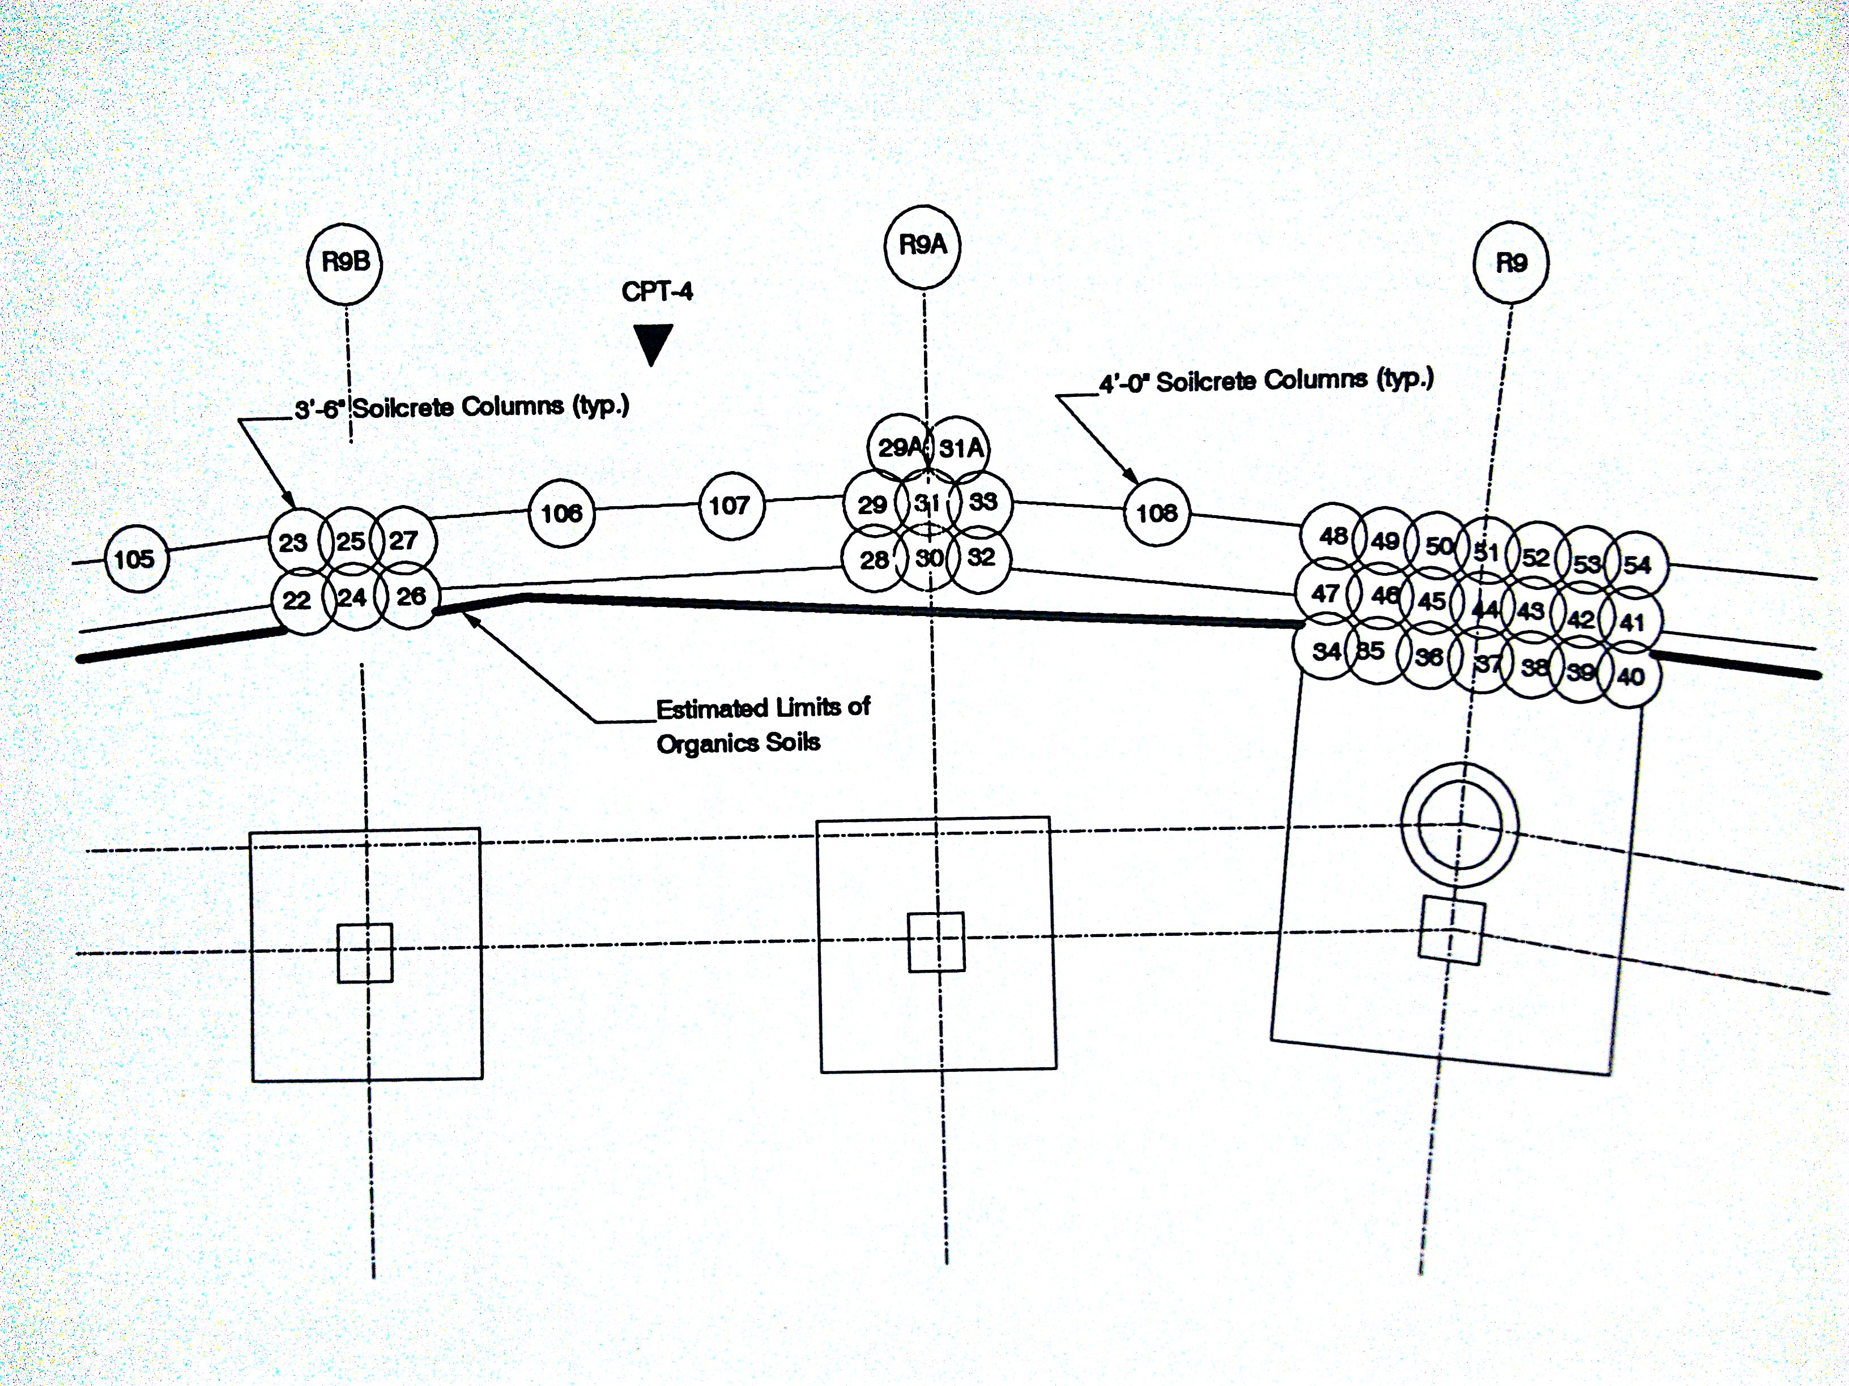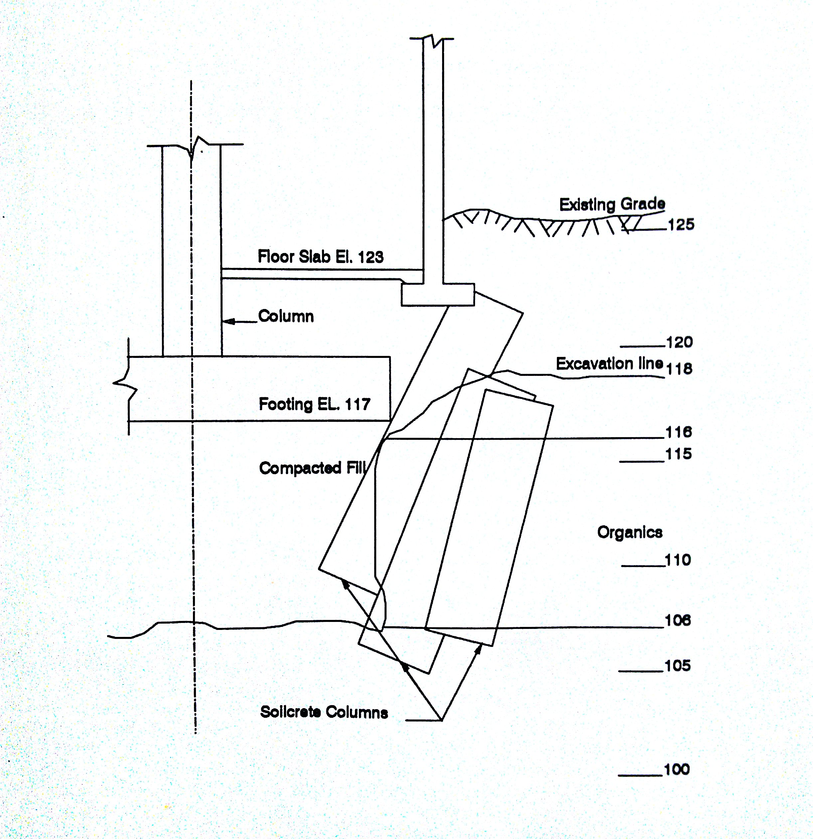
LAB TESTS AND RESULTS:
The following tests were performed on the mixes and the hardened product.
- ASTM C138 Standard Test Method for Unit Weight, Yield, and Air Content of Concrete.
- ASTM C939 Standard Test Method for Flow of Grout for Preplaced-Aggregate Concrete.
- ASTM C873 Standard Test Method for Compressive Strength of Concrete Cylinders Test Cast in Place in Cylindrical Molds.
- Change in Volume due to bleeding.
- Permeability.
The results of unconfined compression test and change in volume due to bleeding performed on samples obtained from these mixes are summarized in tables 2 and 3.
Table 2) Results of Unconfined Compressive Strength Grout and Grout-Soil Mixes
 | Unconfined Comp. Strength (MPa)
 |  | Soilcrete
 | Grout | CL
Baseline | 20.2 | 2.9
SFHR | 23.4 | 2.8
FWR | 42.8 | 2.8
FAWR | 40.5 | 5.7

The results of the shrinkage due to bleeding were an important factor that may influence the choice of admixture which is to be used in the grouting process. Table 4 shows the
Table 3) Change of Volume due to Bleeding of Grout and Grout-Soil Mixes
 | Change of Volume (%)
 |  | Soilcrete
 | Grout | CL
Baseline | 1.2 | 0.70
SFHR | 1.35 | 0.45
FWR | 1.4 | 0.60
FAWR | 1.3 | 0.50

CONCLUSIONS
The project was done successfully and the settlement was stopped. During construction process settlement was less than 5 mm.
From the results of testing the following general conclusions were drawn:
- Jet grouting could be the most beneficial method of underpinning in case of high depths below the structure or underground.
- For underpinning problems, dealing with this method can be useful for soft soils.
- In general, no need to stop using the subject part of structure for more than the number of days needed for construction.
- No need for excavation and shoring is needed.
- No need to remove the tiles and rune any finishing works.
REFERENCES:
Alsayyedahmad, M. T., “Properties of Cement Based Grouts and Soilcrete and Jet Grouting Applications”, Ph.D. Thesis, The University of Akron, 1992.
Andromalos, K. B. and Gazawy, H. N., “Jet Grouting to Construct a Soilcrete Wall Using Twin System”, Geo-Con, Pittsburgh, 1989, 12pp.
Aschieri, F., Jamiolkowski, M., and Tornaghi, R., “Case History of a Cut-Off Wall Executed by Jet Grouting”, Proceedings of the 8th European Conference on Soil Mechanics and Foundation Engineering, Helsinki, 23-26 May 1983, Vol. 1, pp. 121-126.
Burke, G. K., Heller, R. A., and Johnson, L. E., “Jet Grouting Underpinning the Cutting Edge”, Geotechnical News, Vol. 7, no. 1, March 1989, 4 pp.
Gosaburo, M., “The Newest Techniques on Chemical Grouting and Jet Grouting, “Symposium on Recent Developments in Ground Improvement Techniques, Bangkok, 29 Nov. – 3 Dec. 1985, pp 279-288.
Miki, G. and Nakanishi, W., ”Technical Progress of the Jet Grouting Method and Its Newest Type”, Proceedings of International Conference on In-Situ Soil and Rock reinforcement, Vol. I, Paris, 1984, pp. 195-200.
Yahiro, T. Yoshida, H. and Nishi, K., “The Development and Application of a Japanese Grouting System”, Water Power and Dam Construction, Feb 1975, pp. 56-59.

