**Behaviour of RC Beams Strengthened with NSM Steel and CFRP Bars**

Mohd Zamin Jumaat, Md. Akter Hosen, Kh. Mahfuz Ud Darain, M. Obaydullah

Department of Civil Engineering, Faculty of Engineering, University of Malaya,

50603, Kuala Lumpur, Malaysia.

Email: [zamin@um.edu.my](mailto:zamin@um.edu.my); [enggakter@gmail.com](mailto:enggakter@gmail.com); [khmahfuz@gmail.com](mailto:khmahfuz@gmail.com); [md_obaydullah@yahoo.com](mailto:md_obaydullah@yahoo.com)

***Abstract*—Strengthening of structural members are now quite common in the construction industry due to a number of reasons. These include the increase in loading requirements, change in the type of usage and even due to deficiencies in either material properties or design of the structure. Flexural strengthening using near surface mounted (NSM) technique currently is getting more popular compared to the externally bonded reinforcement (EBR) technique. Most of the research works on NSM technique of strengthening reinforced concrete (RC) beams are focused on using carbon fiber reinforced polymer (CFRP) because of its good resistance to corrosion. This paper presents an experimental study on the flexural strengthening of RC beams with NSM steel or CFRP bars, and NSM steel together with the U-wrap end anchorage using CFRP fabrics. Four point bending tests were carried out on six rectangular RC beams (125 mm width by 250 mm depth by 2300 mm length). The first cracking and ultimate load, displacement and failure modes were presented in the paper. The test results showed that the ultimate loads for all strengthened beams increased significantly. The CFRP-end anchorage eliminated the concrete cover separation failure and the ductility was found to have improved to quite an extent.**

***Keywords-flexural strengthening; NSM, concrete cover separation; CFRP fabrics.***

# INTRODUCTION

Nowadays, there is an emerging demand for the upgrading of existing infrastructures all around the world. There are a number of methods for strengthening existing reinforced concrete structures. Externally bonded reinforcement (EBR) and the near surface mounted (NSM) technique are among the most popular strengthening methods [1-5].

The EBR technique comprises the external bonding of strengthening materials such as steel plates or fiber reinforced polymer (FRP) laminates. However, this technique suffers from the high possibility of premature failure such as debonding of longitudinal laminates, delamination and other types of premature failure. This prevents the strengthened members from achieving the ultimate flexural capacity [6-8]. Moreover, the externally bonded steel or FRP plates are vulnerable to thermal, environmental and mechanical damage. Therefore, the NSM strengthening technique offers an effective substitute to the EBR technique. In the NSM method the surrounding concrete protects the NSM bars or strips from thermal, environmental and mechanical damage, as well as delaying or preventing premature failure.

The first experimental research on the NSM technique using CFRP strips in grooves cut into the concrete specimens was conducted by Blaschko[9]. This was followed by a number of experimental studies which investigated the flexural behavior of RC beams strengthened with NSM bars or strips using FRP materials [10-14]. FRP reinforcement has various advantages such as high strength, light weight, resistance to corrosion and potentially high durability but is highly expensive. In addition, FRP reinforcements have little ductility.

Usage of steel bars are in NSM technique has not been popular due to the tendency of steel to corrode easily without adequate cover. However steel is readily available, less expensive, show adequate ductility, had long-term durability and good bond performance [15].

NSM technique also has some limitations. The width of the beam to be strengthened may not be wide enough to provide necessary edge clearance and clear spacing between adjacent NSM grooves [16]. Moreover, RC beams strengthened with NSM technique using FRP (CFRP and AFRP) bars were prone to fail by debonding between the FRP bars and the epoxy interface [17,18]. Furthermore, concrete cover separation failure modes could also occur when beams were strengthened the NSM technique [19].

In this study, the use of U-wrap end anchorage using CFRP fabrics was investigated to see its potential in preventing debonding failure due to concrete cover separation in flexurally strengthened NSM-steel RC beams. The cracking and ultimate loads, mid-span displacement and failure modes were analyzed.

# EXPERIMENTAL PROGRAM

*A. Test Matrix*

A total of six full size RC rectangular beams have been considered as test specimens. The beams were divided into four groups as shown in Table I. The first group consisted of one beam as the control specimen (unstrengthened). Two specimens in the second group were strengthened with NSM steel bars. One specimen in the third group were strengthened NSM CFRP bars. Another two specimens in the fourth group were strengthened by NSM steel bars and end anchored with CFRP fabrics.

TABLE I. TEST MATRIX

|  |  |  |  |  |
| --- | --- | --- | --- | --- |
| **Beam ID** | NSM strengthening materials | | | End anchorage with CFRP fabrics |
| ***Type*** | ***Diameter (mm)*** | ***Number of bars*** |
| CB | unstrengthened | | | |
| NS10 | Steel bars | 8 | 2 | - |
| NS12 | 10 |
| NC12 | CFRP bars | 12 |
| NS10U | Steel bars | 10 | 3 layers |
| NS12U | 12 | 3 layers |

*B. Specimen Configuration*

The dimensions and reinforcement details of the prototype specimens are shown in Fig. 1. The beams were designed as under reinforced (*ρ* = *As/bd* = 0.0084) beams to initiate failure in flexure, in accordance with the ACI code [20]. The cross-sectional dimensions of the beams were 125 mm x 250 mm and the length of the beams was 2300 mm. The effective span and shear-span length of the beams are 2000 mm and 650 mm respectively. The internal tension reinforcement of all beams consisted of two deformed steel bars, 12 mm in diameter, which were bent ninety degrees at both ends to fulfil the anchorage criteria. Furthermore, two steel bars of 10 mm diameter were used as hanger bars in the shear span zone. The shear reinforcement consisted of plain steel bars, 6 mm in diameter, distributed along the length of the beams as shown in Fig. 1a.

650 mm

650 mm

700 mm

φ6 mm @ 50 mm

2 No.10 mm

P/2

2 No.12 mm

P/2

A

A

2000 mm

1. Control beam

Section A - A

75 mm

250 mm

225 mm

125 mm

1900 mm

B

(b) NSM-steel without end anchors

B

Section B - B

NSM Bar

Epoxy

1.5 db

1.5 db

1900 mm

(c) NSM-steel with end-anchors

50 mm

100 mm width

CFRP U-wrap

(d) Detail of anchorage

Fig. 1: Beam specimens details

## *C. Material properties*

All beam specimens were cast using ordinary Portland cement. Crushed granite of maximum size 20 mm was used as coarse aggregate. Local mining sand was used as fine aggregate. Fresh tap water hydrated the concrete mix during the casting and curing of the beams, cubes, prisms and cylinders. The mix design of the concrete was carried out in accordance with the DOE method [21]. The 28 days average compressive strength, flexural strength and modulus of elasticity of the concrete was 40 MPa, 4.5 MPa and 29875 MPa respectively based on tests of concrete three 100 mm x 100 mm x 100 mm cubes, 100 mm x 100 mm x 500 mm prisms and 150 mm x 300 mm cylinders. The properties of the reinforcing steel bars are presented in Table II. The CFRP fabrics thickness, ultimate strength and modulus of elasticity were 0.17 mm, 4900 MPa and 230 GPa respectively. The CFRP bars tensile strength and modulus of elasticity were 1861 MPa and 127 GPa respectively. Sikadur® 30, an epoxy adhesive, was used to bond the strengthening bars to the concrete substrate. Sikadur® 330 was used to bond the CFRP fabrics to the concrete substrate.

TABLE II. PROPERTIES OF REINFORCING BARS

|  |  |  |  |
| --- | --- | --- | --- |
| **Diameter, (mm)** | **Yield strength, (MPa)** | **Ultimate strength, (MPa)** | **Modulus of elasticity,**  **(GPa)** |
| 6 | 520 | 570 | 200 |
| 10 | 520 | 572 |
| 12 | 550 | 640 |

## *D. Strengthening Procedure*

*(i) Application of NSM-steel bars*

In NSM-steel technique, strengthening bars are placed into grooves cut into the concrete cover of the RC beams and bonded using an epoxy adhesive groove filler. The installation of the strengthening steel bars began with the cutting of grooves maintaining the dimensions 1.5*db* x 1.5*db* (where *db* is the diameter of the tension reinforcement) into the concrete cover of the beam specimens at the tension face in the longitudinal direction. The grooves were made using a special concrete saw with a diamond blade. A hammer and a hand chisel were used to remove any remaining concrete lugs and to roughen the lower surface of the groove. The grooves were cleaned with a wire brush and a high pressure air jet. The strengthening steel bars were clean with acetone before introducing them into the grooves, in order to remove any possible dirt. The details of the grooves are shown in Fig 1c. The grooves were half filled with epoxy and then the steel bar was placed inside the groove and lightly pressed. This forced the epoxy to flow around the inserted steel bar. In addition, required epoxy was used to fill the groove and level the surface. The bonded length of the NSM steel bars were 1900 mm. To ensure the epoxy achieved full strength, the beam was kept for one week of curing time.

*(ii) Application of end anchorage*

After the curing period, the concrete surface at the ends of the beams to be anchor wrapped were prepared based on epoxy adhesive (Sikadur® 330) specification requirements. The surface was cleaned using brush and air jet. Finally, acetone was used to remove the dust and any other materials, which affect the bonding. A thin layer of adhesive was applied on the concrete surface to make sure that the adhesive fully covers the concrete surface. After that, CFRP fabrics were placed on the beam soffit and two sides and covered with epoxy adhesive. To achieve full strength of the epoxy, the beam was kept for another one week of curing time.

## *E. Experimental Setup*

The beams instrumentations are shown in Fig. 2. To measure the deflection at mid span of the beam, one vertical linear variable differential transducers (LVDT) was used. Two 5 mm strain gauges were attached at the middle of the internal tension bars. A 30 mm strain gauge was placed on the top surface of the beam at mid span. The demec gauges were attached along the depth of the beam at mid span.

All the beams were tested in four-point bending using an Instron Universal Testing Machine. Test was carried out two types of control. The first stage was load control, which was applied until the loads were close to the yield of the main reinforcement steel of the beam and the second stage was displacement control until the failure of the beam. All the data were recorded at every 10 second intervals using data logger. The rate of actuator was set to 5 kN/min during load control and 1.5 mm/min during displacement control. A dino-lite digital microscope was used to measure the crack width of beams during the test.

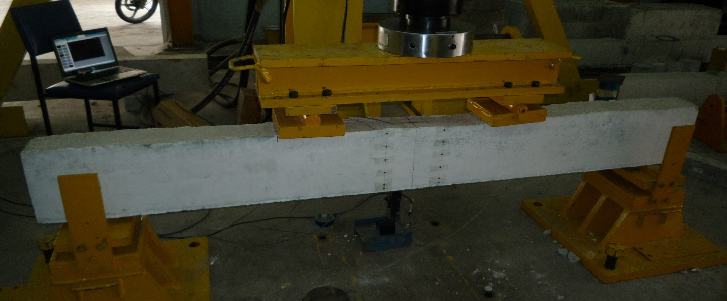

Fig. 2: Experimental setup

# RESULTS AND DISCUSSIONS

The leading aspects considered in this studies are cracking load, ultimate load, mid-span displacement and modes of failure. The results of the tested beams are given in Table III.

TABLE III. SUMMARY OF BEAM TEST RESULTS

|  |  |  |  |  |  |  |
| --- | --- | --- | --- | --- | --- | --- |
| **Beam ID** | **First crack load (kN)** | **Increased first crack load (%)** | **Ultimate load (kN)** | **Increased ultimate load (%)** | **Displacement at failure (mm)** | **Failure modes** |
| CB | 15.75 | - | 74.37 | - | 33.61 | FL |
| NS10 | 21.00 | 33.33 | 117.75 | 58.33 | 15.62 | CC |
| NS12 | 26.60 | 68.89 | 136.75 | 83.88 | 11.95 | CC |
| NC12 | 25.00 | 58.73 | 146.03 | 96.35 | 12.93 | CC |
| NS10U | 27.00 | 71.43 | 153.78 | 106.78 | 34.14 | FL |
| NS12U | 31.50 | 100.00 | 160.76 | 116.16 | 30.67 | FL |

*FL- flexural failure, CC- concrete cover separation.

## *A. Load-Deflection Curve*

The load versus mid-span displacement curves for the control, and the beams strengthened with NSM steel and CFRP bars, and NSM steel bars together with end anchorage are shown in Fig. 3.

All the strengthened beams showed the linear elastic behavior of displacement at the commencing of the followed by the first crack. In this stage, the NSM bars induced a significant influence on the stiffness of the load-displacement curves. So the first cracking load increased by 33%, 69%, 59%, 71% and 100% for NS10, NS12, NC12, NS10U and NS12U respectively, compared the control beam. The second stage, the NSM bars strengthened beams reached the ultimate stage and failed by debonding such as concrete cover separation. Before failure, the ultimate load increased by 58%, 84% and 96% for NS10, NS12 and NC12 respectively, compared to the control beam. By contrast, the NSM steel bars with end anchors strengthened beams shown many flexural cracks and smaller displacements except NS12. At the failure stage, the beams strengthened with NSM steel bars and end-anchored showed more displacement compared to the beams strengthened with NSM bars (steel/CFRP). The reason being that the specimens strengthened with NSM steel bars and end-anchored eliminate concrete cover separation failure and enhanced the ultimate loads. Therefore, NSM-steel with end anchors increased ultimate load by 107% and 116% for NS10U and NS12U respectively, compared to the control beams.

Fig. 3: Load vs. displacement at mid-span for all beams.

## *B. Mode of Failure*

The failure modes of NSM steel and CFRP bars strengthened beams are shown in Fig. 4b, 4c and 4d, and NSM steel together with U-wrap end anchorage are shown in Fig. 4e and 4f.The results show that the strengthened beams without end anchors failed by separation of the concrete cover in a brittle mode. However, the strengthened beams with NSM steel bars with end anchors failed in flexure in a ductile failure mode.

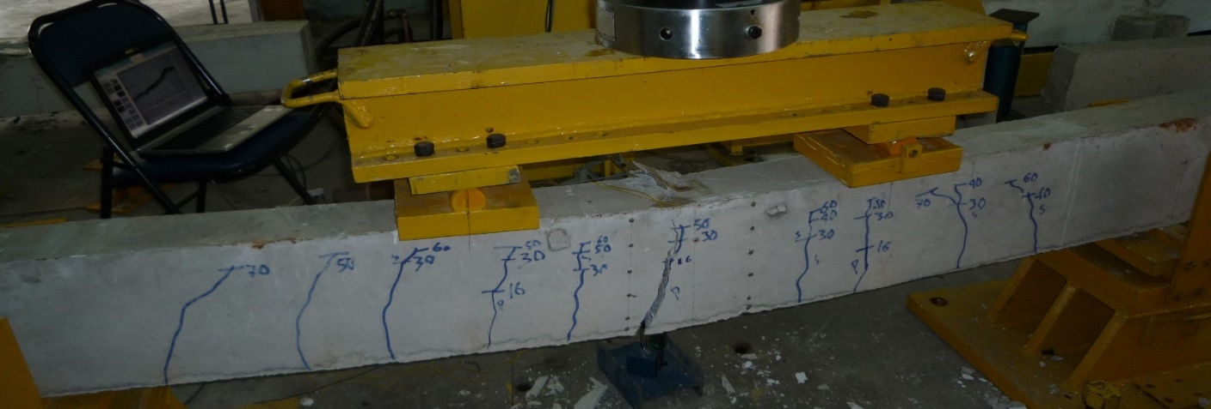

(a) CB

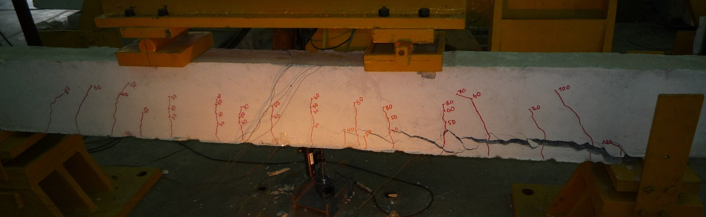

(b) NS10

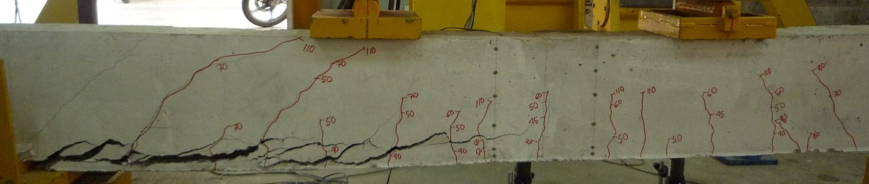

(c) NS12

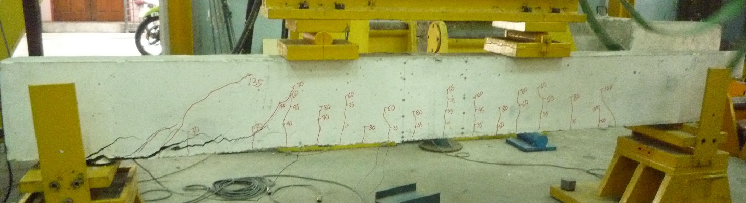

(d) NC12

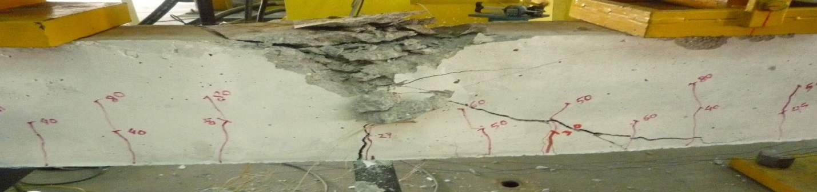

(e) NS10U

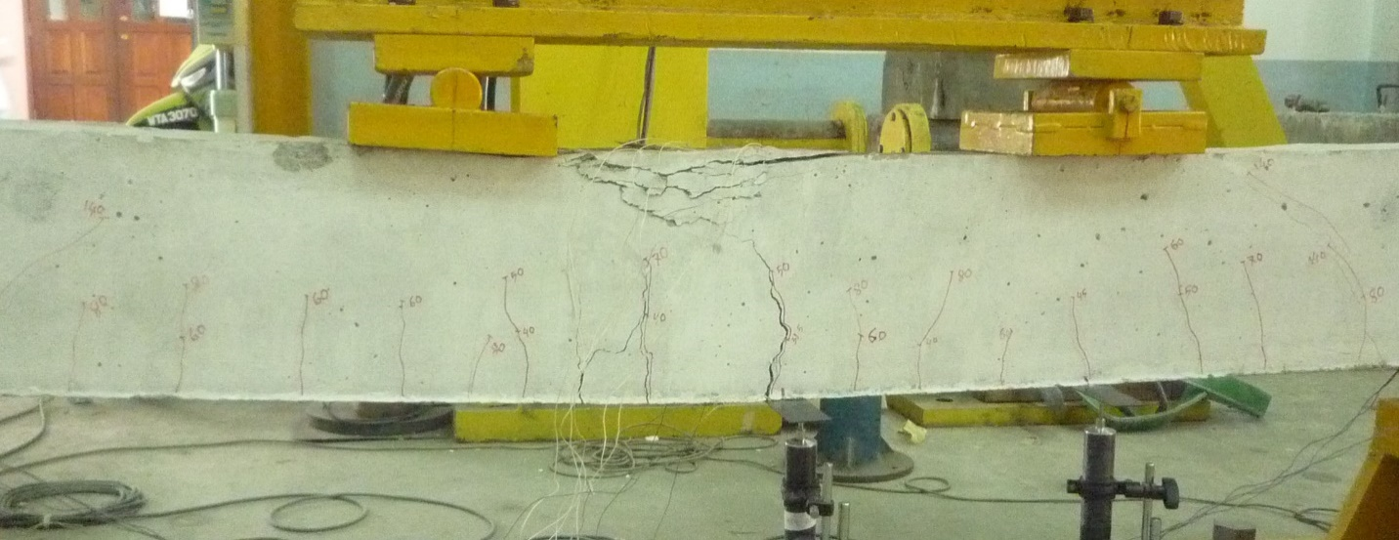

(f) NS12U

Fig. 4: Failure modes of beam specimens

# CONCLUSIONS

The following conclusions can be drawn from the experimental results:

* The strengthened beams enhanced the first cracking and ultimate loads, and reduce the displacement at any load level compared to the control beam.
* The beams with NSM steel strengthening without end anchors had the first cracking and ultimate loads increased up to 69% and 84% respectively compared to the control beam.
* The beam with NSM CFRP strengthening without end anchors had the first cracking and ultimate loads increased up to 59% and 96% respectively compared to the control beam.
* The NSM CFRP strengthened beam had higher ultimate capacity compared to NSM steel due to higher tensile strength of CFRP bars.
* The beams strengthened with steels using the NSM technique together with end anchors showed an increase in the first cracking and ultimate load up to 100% and 116% respectively, compared to the control beam.
* The NSM strengthened beams without end anchorages failed by concrete cover separation and shows brittle behavior.
* The NSM strengthened beams with end anchorage failed by flexure. So, the U-wrap end anchorage prevent the concrete cover separation failure.

ACKNOWLEDGMENT

The authors gratefully acknowledge the support given by University of Malaya (UM) for funding the study through the High Impact Research Grant UM.C/HIR/MOHE/ENG/36 (D000036-16001).

# REFERENCES

1. ACI, A., 440.2 R-02: Guide for the design and construction of externally bonded FRP systems for strengthening concrete structures. Farmingtion Hills, Michigan, American Concrete Institute, 2002.
2. Barros, J. A., Dias, S. J., & Lima, J. L. Efficacy of CFRP-based techniques for the flexural and shear strengthening of concrete beams. Cement and Concrete Composites 2007; 29(3): 203-217.
3. Barros, J. A., & Kotynia, R. Possibilities and challenges of NSM for the flexural strengthening of RC structures. Fourth International Conference on FRP Composites in Civil Engineering (CICE2008) 22-24July 2008, Zurich, Switzerland.
4. Akbarzadeh, H., & Maghsoudi, A. A. Experimental and analytical investigation of reinforced high strength concrete continuous beams strengthened with fiber reinforced polymer. Materials & Design 2010; 31(3): 1130-1147.
5. Zhou, Y., Gou, M., Zhang, F., Zhang, S., & Wang, D. Reinforced concrete beams strengthened with carbon fiber reinforced polymer by friction hybrid bond technique: Experimental investigation. Materials & Design 2013; 50: 130-139.
6. Brena, S. F., Bramblett, R. M., Wood, S. L., & Kreger, M. E. Increasing flexural capacity of reinforced concrete beams using carbon fiber-reinforced polymer composites. ACI Structural Journal 2003; 100(1): 36-46.
7. Nguyen, D. M., Chan, T. K., & Cheong, H. K. Brittle failure and bond development length of CFRP-concrete beams. Journal of Composites for Construction 2001; 5(1): 12-17.
8. Hawileh, R. A., Rasheed, H. A., Abdalla, J. A., & Al-Tamimi, A. K. Behavior of reinforced concrete beams strengthened with externally bonded hybrid fiber reinforced polymer systems. Materials & Design 2014; 53: 972-982.
9. Blaschko, M., & Zilch, K. Rehabilitation of concrete structures with CFRP strips glued into slits. In Proceedings of the 12th international conference on composite materials 1999: 5-9.
10. Soliman, S. M., El-Salakawy, E., & Benmokrane, B. Flexural behaviour of concrete beams strengthened with near surface mounted fibre reinforced polymer bars. Canadian Journal of Civil Engineering 2010; 37(10): 1371-1382.
11. El-Hacha, R., & Gaafar, M. Flexural strengthening of reinforced concrete beams using prestressed, near-surface-mounted CFRP bars. PCI journal 2011; 56(4): 134-151.
12. De Lorenzis, L., Nanni, A., & La Tegola, A. Strengthening of reinforced concrete structures with near surface mounted FRP rods. In
13. International Meeting on Composite Materials, PLAST 2000, Proceedings, Advancing with Composites (pp. 9-11).
14. Badawi, M., & Soudki, K. Flexural strengthening of RC beams with prestressed NSM CFRP rods–experimental and analytical investigation. Construction and Building Materials 2009; 23(10): 3292-3300.
15. Al-Mahmoud, F., Castel, A., François, R., & Tourneur, C. Strengthening of RC members with near-surface mounted CFRP rods. Composite Structures 2009; 91(2): 138-147.
16. [15]. Rahal, K. N., & Rumaih, H. A. Tests on reinforced concrete beams strengthened in shear using near surface mounted CFRP and steel bars. Engineering Structures 2011; 33(1): 53-62.
17. De Lorenzis, L., & Teng, J. G. Near-surface mounted FRP reinforcement: An emerging technique for strengthening structures. Composites Part B: Engineering 2007; 38(2): 119-143.
18. El-Hacha, R., & Rizkalla, S. H. Near-surface-mounted fiber-reinforced polymer reinforcements for flexural strengthening of concrete structures. ACI Structural Journal 2004; 101(5): 717-726.
19. Kishi, N., Mikami, H., Kurihashi, Y., & Sawada. Flexural behaviour of RC beams reinforced with NSM AFRP rods. In Proceedings of the International Symposium on Bond Behaviour of FRP in structures, BBFS 2005: 337-342.
20. Sharaky, I. A., Torres, L., Comas, J., & Barris, C. Flexural response of reinforced concrete (RC) beams strengthened with near surface mounted (NSM) fibre reinforced polymer (FRP) bars. Composite Structures 2014; 109: 8-22.
21. ACI 318-11. Building Code Requirements for Structural Concrete and Commentary. ACI Committee 2011; 11:503.
22. Department of the Environment. Design of normal concrete mixes. Building Research Establishment, Watford, U.K. 1988: 42 pp.