Major steps needed towards earthquake resistant design

Abdul Razzaq Touqan
Civil Engineering Department
An-Najah National University
Nablus, Palestine
touqanar2000@najah.edu
Suhaib Salawdeh
Civil Engineering Department
An-Najah National University
Nablus, Palestine
Suhaib.salawdeh@najah.edu

Abstract—the main lesson learned from past earthquakes is the need to make matching between reality and mathematical model. The structure responds according to real prevailing conditions at site and not according to the mathematical model used in the engineering offices. Since earthquakes hit the whole structure dynamically, a 3D dynamic analysis of structures is the main step needed after the first important step of conceptual configuration. Designing structures elastically to resist large earthquakes is unrealistic in terms of optimizing cost against such a random phenomenon. Thus nonlinear (both geometry and materials) and probabilistic studies are also necessary steps to achieve such goals. The paper will address all previous points in a systematic way emphasizing challenging local areas needed to be solved. Making design of earthquake resistant structures enforced by law implies a continuous learning and development process to be monitored to enhance possibilities of success especially when we are far from achieving many main principal issues.
Keywords-seismic design; design codes; UBC; Eurocode 8; IBC.

Introduction
The UNDP [1] found that about 130 million people are exposed on average every year to earthquake risk all around the world. High relative vulnerability (people killed/injured) was found in developing countries. It is not the Earthquake, which kills people, it is the man-made-constructions that do. Moreover, ignorance acts before, during and after the earthquake can also be a major factor in increasing casualties. In our region, devastating earthquakes have occurred in the past, such as the 1927 Palestine earthquake (also called Jericho Earthquake). Many Palestinian cities were heavily damaged, thousands of people were left homeless and at least 500 were estimated to be killed. Figure 1 [2] shows an example of a structure damaged in the 1927 Palestine Earthquake.
According to experts, similar to 1927 Palestine earthquake may occur in near future. It is not possible to predict when this earthquake will occur, but it is better to be prepared for it to minimize the losses (e.g. save lives and properties). This can be done if structures are properly designed to withstand earthquakes.
The authorities in Palestine have mandated that all new buildings over four stories in height should be designed to
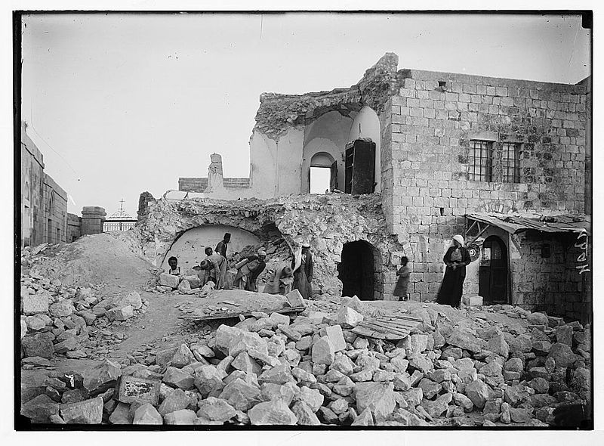
Figure 1: A destroyed house in Jerusalem. [2]
resist earthquakes. To achieve this, they enforced Uniform Building Code (UBC) 1997 [3] or equivalent codes to control structural design of buildings. The UBC was replaced in 2000 by the new International Building Code (IBC) 2000 [4] published by the International Code Council (ICC) and updated editions of the IBC are published on a three year cycle (2003, 2006, 2009, 2012) [5,6,7,8].
The Poisson model is the standard model for seismic risk analysis. Stein and Wysession (2003) [9] claimed that this model is not the best model for large earthquake occurrence in which the tectonic stress is released when a fault breaks and must rebuild before the next one can occur at that location, however, it is still the most used model.
According to the Poisson model, the probability of at least one earthquake equal to or greater than a specific magnitude (M) occurring within t years is
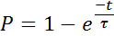 | [1]
where τ is the average recurrence interval for this earthquake. For 2 and 10 percent probability of exceedance in 50 years that are commonly considered in earthquake engineering (2% in IBC [8] and 10% in UBC [3] and Eurocode 8 [10]) gives τ of 2500 and 475 years, respectively, for earthquakes with a certain magnitude or greater.
The seismic ground motions with probability of exceedance, 10% in 50years, were used as the design earthquake in the UBC before introducing the IBC.
Kennedy and short [11] indicated that if a structure is subjected to a ground motion 1.5 times the design earthquake, the structure may not collapse but if the ground motions are greater than 1.5 times the design earthquake the structure may collapse. Because of that the UBC used for design ground motions with 10% probability of exceedance in 50 years and for safety the seismic margin equals to 1.5 times the design earthquake will be present.
It is found that the difference between the 10% in 50 years ground motion and the 2% in 50 years ground motion in the active seismic areas such as California is nearly 1.5 (see Figure 2). However, the difference between these two probabilities in less active seismic areas in the eastern part of the states such as south Carolina is much more than 1.5 (see Figure 3) [12].
Figure 2: Uniform hazard response spectra for 2% and 10% probability of exceedance in 50 years for San Francisco [12].
Figure 3: : Uniform hazard response spectra for 2% and 10% probability of exceedance in 50 years for in south Carolina [12].

In order to provide a uniform level of safety across the US against collapse in the maximum considered earthquake, the IBC defined the 2% probability of exceedance in 50 years as the seismic margin, that is, the maximum considered earthquake (MCE), and determined the design earthquake equal to two-third (the reciprocal of 1.5) of MCE [12].
In IBC, the maximum considered earthquake spectral response accelerations for short periods, S_{MS}, and at 1 second period, S_{M1}, adjusted for site class effect is determined from the following equations:
S_{MS} = F_{a}S_{S} | [2]
S_{M1} = F_{v}S₁ | [3]
where F_{a} and F_{v} are site coefficients and S_{S} and S₁ are mapped parameters that indicate the 5% damped spectral acceleration of the Maximum Considered Earthquake (MCE) in short and long periods (0.2s and 1.0s), respectively. The design spectral acceleration parameters in IBC are S_{DS} and S_{D1} rather than seismic zone factor used in UBC and can be found by:
S_{DS} = (2/3)S_{ms} | [4]
S_{D1} = (2/3)S_{M1} | [5]

Our region is similar in seismicity to the eastern parts of the states. Thus, we recommend using 10% probability of exceedance in 50 years, therefore, IBC can be used without using equations [4] and [5] (i. e. S_{DS} = S_{ms} and S_{D1} = S_{M1}).

Earthquake design principles
To enable the designer to estimate the design forces generated by seismic ground motion in buildings, several levels of analysis are available as shown in Figure 4.
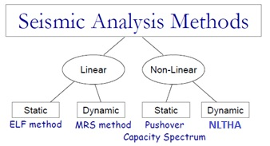
Figure 4: Seismic analysis methods.
This starts by the detailed non-linear time history analysis (NLTHA), to pushover analysis, to the modal response spectrum (MRS) method, and reaches the most simplified method, which is the equivalent lateral force (ELF) procedure, which is adapted in design codes.
The Equivalent Lateral Force method considers only the fundamental mode of vibration and is therefore only permitted for regular structures.
The modal response spectrum method is based on the same concepts as the equivalent force procedure, but instead of considering the fundamental mode response only, the approach attempts to account for higher mode actions too. According to current codes, the approach can be applied to different building types if satisfies the codes requirements. Given this, and the fact that there are a large number of commercial software packages that automate the approach, it is currently the design approach used by many designers.
The pushover approach is essentially an assessment method. The approach proceeds by establishing an equivalent lateral force-displacement curve for the structure. This curve is then plotted together with the design response spectrum & the expected response point is identified.
NLTHA currently offer the most accurate analysis tool for seismic engineers. However, codes do not provide much guidance for their use and the approach requires significant expertise. Table 1 summarizes the advantages and disadvantages of each analysis method.
Table 1: Seismic analysis methods.
Analysis Method | Advantages | Disadvantages
The equivalent lateral  force method | Fast! Simple! Few modelling decisions necessary. | Cannot be used for vertically irregular or tall buildings. Does not consider carefully non- linear effects on the response.
The modal response  spectrum method | A fairly simple and fast method when in possession of a suitable commercial analysis software. Is a real “design” method. | Does not consider carefully non-linear effects on the response. Sensitive to modelling decisions.
The pushover  method | Considers non-linear response! Is fast compared to NLTHAs! | Does not consider dynamic effects well. Currently limited to systems dominated by 1st mode response.
Non-linear time-history analyses | A very powerful method that can provide accurate indications of response. Can be used for all structural types. | Requires significant expertise: is difficult and slow & sensitive to modelling decisions.

Fundamental requirements
Two fundamental requirements for designing and constructing every structure in a seismic region are given below [10]
- No-collapse requirement: where the structure is designed and constructed to withstand the design seismic actions without local or global collapse, and to retain full load bearing capacity after the seismic events. After the earthquake, there should be sufficient lateral strength and stiffness to protect the structure from collapse if aftershocks occurred taking into account the importance of the structure. For normal structures, a design life of 50 years is utilized, with an earthquake of a return period of 475 years resulting in ground motion parameters that carry a 10% probability of being exceeded.
- Damage limitation requirement: where the structure is designed and constructed to withstand a seismic action with a larger probability of occurrence than the design seismic actions. The cost of damage and the associated limitations of use should not be disproportionately high in comparison with the cost of the structure itself. The damage limitation requirement has a 10% probability of being exceeded in 10 years with a return period of 95 years.

Basic principles of conceptual design
Some aspects for buildings in seismic regions are set out in the codes. These aspects should be taken into account in the early stages of the conceptual design of the building, thus enabling the achievement of a structural system, which, within acceptable costs, satisfies the ‘no-collapse’ and ‘damage limitation’ requirements. The guiding principles governing this conceptual design are the following:
- Buildings should be light (avoid unnecessary masses)
- Structural simplicity.
- Uniformity, symmetry and redundancy.
- Bi-directional resistance and stiffness.
- Torsional resistance and stiffness.
- Diaphragmatic behaviour at storey level.
- Adequate foundation.
Reliability differentiation is implemented by classifying structures into different importance categories.

Importance classes and importance factors
EC8 [10] and IBC [4-8] classify buildings in 4 importance classes with different importance factors, γ in EC8 and I in UBC, depending on the consequences of collapse for human life, on their importance for public safety and civil protection in the immediate post-earthquake period, and on the social and economic consequences of collapse. The definitions of the importance classes are given in Table 2 for both codes. The importance factor is used to alter the seismic event reference return period. In other words, those buildings in higher importance classes have greater reference return periods for seismic design. In order to limit the consequences of the seismic event, National Authorities may specify restrictions on the height or other characteristics of a structure depending on local seismicity, importance category, ground conditions, city planning and environmental planning.
UBC [3] defines different importance factors depending on the occupancy categories. The categories are essential facilities, hazardous facilities, special occupancy structures and standard occupancy structures with recommended importance factors values given in Table 2 equivalent to EC8 and IBC as 1.25, 1.25, 1 and 1 respectively.

Table 2: Importance classes for buildings for different codes.
Import.  class | Buildings | EC8 | IBC | Equiv. UBC
I | Buildings of minor importance for public safety, e.g. agricultural buildings, etc. | 0.8 | 1 | 1
II | Ordinary buildings, not belonging in the other categories. | 1 | 1 | 1
III | Buildings whose seismic resistance is of importance in view of the consequences associated with a collapse, e.g. schools, assembly halls, cultural institutions etc. | 1.2 | 1.25 | 1.25
IV | Buildings whose integrity during earthquakes is of vital importance for civil protection, e.g. hospitals, fire stations, power plants, etc. | 1.4 | 1.5 | 1.25

Code defined ground motions
In seismic codes, site conditions have been classified into different categories. In EC8 five main ground types A, B, C, D, E and two special ground types S1 and S2 have been described. However, UBC and IBC described six main ground types S_{A}, S_{B}, S_{C}, S_{D}, S_{E}, S_{F}. Table 3 presents ground types and shear wave velocities given in EC8, UBC and IBC.

Response spectrum
The response of buildings with different ranges of periods can be summarised in a single graph called spectrum. This graph is constructed by subjecting a specific earthquake ground motion to a series of structures, each having a different period, T, obtaining the maximum response of each structure, and plotting this as a function of T as shown in Figure 5 [13].
Although each earthquake record will construct different response spectra, earthquakes having similar magnitudes on sites with similar characteristics tend to produce spectra with common characteristics. This has permitted the building codes to adopt standard response spectra that incorporate these characteristics, and which would be anticipated at a building site during a design earthquake. The peaks and valleys in the spectrum obtained from records are averaged to form smooth response spectra to be used in building codes.

Table 3: Ground types defined in the UBC, IBC, and EC8 adapted from [13]
IBC and UBC |  | EC8
Ground type | Description | Ground type | Description
S_{A} | Hard rock Vs >1500 m/s
S_{B} | Rock Vs ≈ 760 – 1500 | A | Rock or rock-like geological formation including most 5 m weaker material at the surface Vs,30 >800 m/s
S_{C} | Very dense soil or soft rock Vs ≈ 360 – 760 | B | Deposit of very dense sand, gravel or very stiff clay, at least several tens of m in thicknesses, characterized by a gradual increase of mechanical properties with depth Vs,30 ≈ 360– 800 m/s
S_{D} | Stiff soil Vs,30 ≈ 180 – 360 | C | Deep deposits of dense or medium-dense sand, gravel or stiff clay with thickness from several tens to many hundreds of m Vs ≈ 180 –360 m/s
S_{E} | Soft soil Vs < 180 | D | Deposits of loose-to-medium cohesionless soil (with or without some soft cohesive layers), or of predominantly soft-to-firm cohesive soil. Vs,30 < 180 m/s
S_{F} | Soil requiring site specific evaluation. It is more detailed defined in the IBC | E | A soil profile consisting of a surface alluvium layer with Vs,30 values of class C or D and thickness varying between about 5 and 20 m, underlain by stiffer material with Vs,30>  800 m/s
 |  | S1 | Deposits consisting or containing a layer at least 10 m thick of soft clays/ silts with high plasticity index (PI > 40) and height water content, Vs,30 < 100 m/s
 |  | S2 | Deposits of liquefiable soils, of sensitive clays, or any other soil profile not included in types A–E  or S1

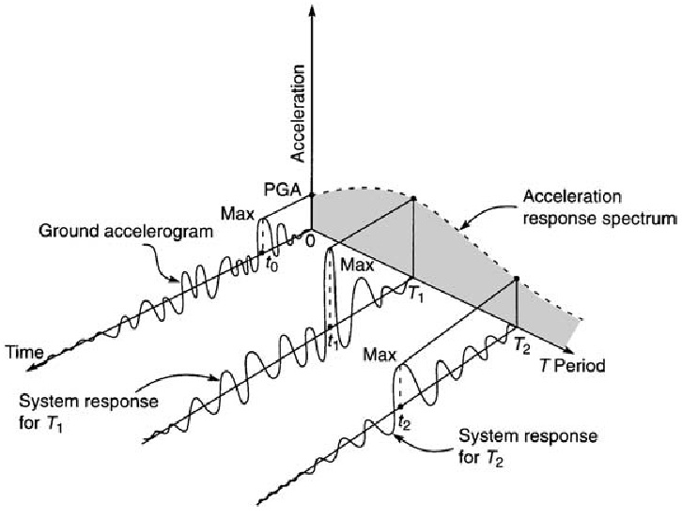
Figure 5: Graphical description of acceleration response spectrum [13]
A typical shape of horizontal elastic design spectrum is shown in Figure 6 [14] where T represents periods of the structure, S_{eA} and S_{eB} show the ordinate values at points A and B of the elastic design spectra, T_{B} and T_{C} show the lower and the upper limits of the period of the constant spectral acceleration branch, and T_{D} shows the value defining the beginning of the constant displacement response range of the spectrum.
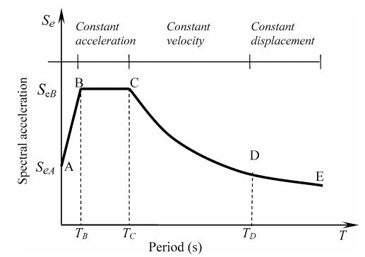
Figure 6: Typical shape of elastic design spectra [14]

EC8 [10] recommends two types (shapes) of spectra. Type 1 is adopted if earthquakes having a surface-wave magnitude, M_{s}, of more than 5.5. A Type 2 spectrum is adopted if M_{s} ≤ 5.5. Each type will have different values of the periods T_{B}, T_{C} and T_{D} and of the soil factor S describing the shape of the elastic response spectrum, which depends upon the ground type the values for both types are listed in Table 4 and 5. For ground types S1 and S2, special studies should provide the corresponding values of S, T_{B}, T_{C} and T_{D}. For 5% viscous damping, S_{eA} = S·a_{g} and S_{eB} = 2.5·S·a_{g} where a_{g} is the peak ground acceleration divided by g.
The elastic response spectrum S_{e}(T) for the horizontal components of the seismic action shown in Figure 6 is defined by Equations [6 - 9].

Table 4: Values of the parameters describing the recommended
Type 1 elastic response spectra EC8 [10].
Ground Type | S | T_{B} | T_{C} | T_{D}
A | 1.0 | 0.15 | 0.4 | 2.0
B | 1.2 | 0.15 | 0.5 | 2.0
C | 1.15 | 0.20 | 0.6 | 2.0
D | 1.35 | 0.20 | 0.8 | 2.0
E | 1.4 | 0.15 | 0.5 | 2.0
Table 5: Values of the parameters describing the recommended Type 2 elastic response spectra EC [10].
Ground Type | S | T_{B} | T_{C} | T_{D}
A | 1.0 | 0.05 | 0.25 | 1.2
B | 1.35 | 0.05 | 0.25 | 1.2
C | 1.5 | 0.1 | 0.25 | 1.2
D | 1.8 | 0.1 | 0.3 | 1.2
E | 1.6 | 0.05 | 0.25 | 1.2

For 0 ≤ T ≤ T_{B} | 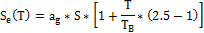 | [6]
For T_{B} ≤ T ≤ T_{C} |  | [7]
For T_{C} ≤ T ≤ T_{D} |  | [8]
For T ≥ T_{D} |  | [9]
The design of structural systems resisting seismic actions generally permits their capacity in the non-linear range to be smaller than those corresponding to a linear elastic response. To do so, a design spectrum, S_{d}, is used. This can be obtained by reducing the ordinates of the reference elastic spectrum, Se, by means of a behavior (reduction) factor, (q in EC8 and R coefficient in UBC) which allows for the ductility expected for the structural system. Seismic codes specify values for the behavior factor, q, depending upon the material of construction and the type of structural system used. However, these values appear to be arbitrary and difficult to justify and different codes uses different behavior (reduction) factors. For example, the behavior factor for high-ductility reinforced concrete moment resisting frame is 5 in EC8 [10] and 8.5 in UBC [3]. Research shows that behavior (reduction) factor is a function of both ductility and period [15].
The design spectrum, S_{d}(T), can be defined for the horizontal components of the seismic action by multiplying the elastic spectra expressions by gγ and divide them by q.
For UBC [3], T_{B} is defined depending on ground types and earthquake zone. The value of T_{B} = 0.2C_{v}/2.5C_{a} where C_{a} is a seismic coefficient shown in Table 6 and C_{v} is a seismic coefficient shown in Table 7. T_{C} is also defined depending on ground types and earthquake zone. T_{C} = C_{v}/2.5C_{a}. T_{D} is not defined in the UBC. S_{eA} = C_{a} and S_{eB} = 2.5·C_{a}
The ordinates of elastic design spectra Se for the reference return period defined by the UBC code can be determined using Equations [10 - 12].
For 0 ≤ T ≤ T_{B} |  | [10]
For T_{B} ≤ T ≤ T_{C} |  | [11]
For T ≥ T_{C} |  | [12]
The design spectrum, S_{d}(T), can be defined for the horizontal components of the seismic action by multiplying the elastic spectra expressions by gI and divide them by R.

Table 6: SEISMIC COEFFICIENT C_{a}
SOIL TYPE | SEISMIC ZONE FACTOR, Z
SOIL TYPE | Z=0.075 | Z=0.15 | Z=0.2 | Z=0.3
SA | 0.06 | 0.12 | 0.16 | 0.24
SB | 0.08 | 0.15 | 0.2 | 0.3
SC | 0.09 | 0.18 | 0.24 | 0.33
SD | 0.12 | 0.22 | 0.28 | 0.36
SE | 0.19 | 0.3 | 0.34 | 0.36

Table 7: SEISMIC COEFFICIENT C_{v}
SOIL TYPE | SEISMIC ZONE FACTOR, Z
SOIL TYPE | Z=0.075 | Z=0.15 | Z=0.2 | Z=0.3
SA | 0.06 | 0.12 | 0.16 | 0.24
SB | 0.08 | 0.15 | 0.2 | 0.3
SC | 0.13 | 0.25 | 0.32 | 0.45
SD | 0.18 | 0.32 | 0.4 | 0.54
SE | 0.26 | 0.5 | 0.64 | 0.84

Capacity design
The capacity design method is a method in which elements of the structural system are chosen and suitably designed and detailed for energy dissipation under severe deformations, while all other structural elements are provided with sufficient strength so that the chosen means of energy dissipation can be maintained.
To illustrate the capacity design concept in a simple way, a ductile chain introduced by Paulay and Priestley [16] shown in Figure 7 is used. The strength of the chain is assumed to equal the strength of the weakest link, which is assumed to provide adequate ductility for the entire chain. The other stronger links are presumed to be brittle. Examples for capacity design in buildings are to make columns stronger than beams in moment resisting frames and making beams and columns stronger than braces in concentrically braced frames.
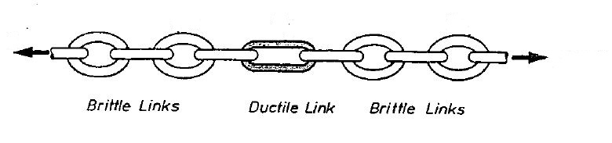
Figure 7: Principle of strength limitation illustrated with ductile chain [16].

Structural materials and types
The structure should have a capacity adequate to dissipate energy without substantial reduction of its overall resistance against horizontal and vertical loading. The requirements of both the ‘no-collapse’ and ‘damage limitation’ should be applied. In other words, adequate resistance of all structural elements shall be provided and non-linear deformation demands in critical regions should be proportionate with the overall ductility assumed in calculations.
Structural material and form used in buildings are influenced by many factors, such as relative cost, environment, locally available skills, functional and aesthetic considerations.
For concrete buildings, EC8 [10] and UBC [3] classify them into many categories. For example, both codes have frame systems and dual systems.
The same applies for steel buildings, where both codes classify them into many categories such as moment resisting frames, and braced frames.

Design Procedure
At the start of the design, preliminary estimates of member sizes should be carried out in order to estimate the elastic stiffness needed to find the fundamental period using Equation [13] (Or, Eigen value analysis, Rayleigh method etc.).
 | 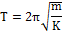 | [13]
Seismic codes use empirical expressions for the period based on a general description of the structural system and its geometry. EC8 [10] and UBC [3] approximates the period, T in seconds, for buildings with heights of up to 40 m by the following expression:
[14]
where both of EC8 [10] and UBC [3] C_{t} is 0.085 for moment resistant space steel frames, 0.073-0.075 for moment resistant space concrete frames and for eccentrically braced steel frames and 0.05 for all other structures, H is the height of the building, in metres, from the foundation or from the top of a rigid basement.
Once the period is determined, the design spectral response acceleration at the fundamental period of the structure, S_{d,} is determined from the design response spectrum. Then, the design base shear can be found and distributed to the floors according to the fundamental mode of vibration. The distribution is modified for large periods to account for higher modes of vibration.
Then the structure can be analysed under the lateral distributed seismic forces and the structural design of members that are meant to dissipate energy can be carried out and the displacements under the seismic actions can be estimated.
If the calculated displacements exceed the code limits, redesign is required. If the calculated displacements are satisfactory, the members that are not meant to dissipate energy and remain elastic can be designed using the capacity design methodology.

Summary and Conclusion
There are differences between UBC [3], EC8 [10] and IBC [4] seismic design provisions. The main difference is that IBC ground motion parameters are S_{DS} and S_{D1}, rather than seismic zone factor.
In this paper, for the design in our region seismic hazard maps for ground motions having 10% probability of exceedance in 50 years is recommended. This is similar to the recommendations of UBC [3] and EC8 [10]. IBC [4-8] can be used if 10% probability of exceedance in 50 years seismic hazard maps are used. If that done, the 2/3 reductions for S_{DS} and S_{D1} should be neglected.
Moreover, Seismic analysis methods to estimate the design forces generated by seismic ground motion in buildings are discussed giving a summary of the advantages and disadvantages of each analysis method.
Finally, a summary of the codified design procedures for ELF are discussed and many similarities for some aspects between the UBC and EC8 were found. However, the ELF has code restrictions and thus the most widely used method is the MRS.

References
- UNDP, Reducing Disaster Risk a Challenge for Development, in United Nations Development Programme, Bureau for Crisis Prevention and Recovery www.undp.org/bcpr2004: New York, NY 10017, USA.
- Matson Photograph Collection. Library of Congress, Washington, D.C., 20540-4730
- International Conference of Building Officials (1997), 1997 Uniform Building Code, Volume 2,2-1, 2–38.
- International Code Council Inc. (2000), 2000 International Building Code, Falls Church, VA, USA.
- International Code Council Inc. (2003), 2003 International Building Code, Falls Church, VA, USA.
- International Code Council Inc. (2006), 2006 International Building Code, Falls Church, VA, USA
- International Code Council, Inc. (2009), 2009 International Building Code, Falls Church, VA, USA.
- International Code Council, Inc. (2012), 2012 International Building Code, Falls Church, VA, USA.
- Stein, S., and Wysession, M., (2003), An introduction to seismology, earthquakes, and earth structure: Maldem, Mass., Blackwell Publishing, 498 p.
- CEN (2004). Eurocode 8, design of structures for earthquake resistance – Part 1: General rules, seismic actions and rules for buildings, EN 1998-1:2004/AC:2009
- Kennedy, R. C., and Short, S. A. (1994). “Basis for seismic provisions of DOE-STD-1020.” Report UCRL-CR-111478, S/C - B235302, Lawrence Livermore National Laboratory, Livermore, CA.
- Leyendecker, E. V., Hunt, R. J., Frankel, A. D., and Rukstales, K. S., 2000. “Development of Maximum Considered Earthquake Ground Motion Maps”, Spectra, Earthquake Engineering Research Institute, Spectra , Oakland, CA.
- Bungale, S. T. (2004). Wind and Earthquake Resistant Buildings Structural Analysis and Design. Boca Raton, FL., CRC Press.
- Dogangun, A., Livaoglu R., (2006), A comparative study of the design spectra defined by Eurocode 8, UBC, IBC and Turkish Earthquake Code on R/C sample buildings., J Seismol 10:335–351
- Chopra, A.K. 2012. Dynamics of Structures: Theory and Applications to Earthquake Engineering. 4th Edition. New Jersey: Pearson Education
- Paulay, T. and M.N.J. Priestley, Seismic Design of Reinforced Concrete and Masonry Buildings. 1992, Wiley, New York

