ANALYTICAL EVALUATION OF A SUDDEN PUNCHING SHEAR
FAILURE FOR POST-TENSIONED CONCRETE FLAT SLABS

Zaher Abou Saleh, assistant professor
Department of Civil Engineering
Beirut Arab University
Debbieh, Lebanon.
z.abousaleh@bau.edu.lb

Abstract-Punching shear often controls the required slab thickness or column size of flat-plate slabs. This paper presents the results of an experimental investigation of the brittle punching shear failure of post-tensioned concrete slabs. The test results are compared with ACI equations for punching shear strength. An analysis accounting for the sudden shear failure at the critical sections is also presented which provided a theoretical equation of the punching shear capacity at service stage.
Keywords: post-tensioned slab; sudden shear failure; punching shear.

INTRODUCTION
Shear strength of flat slabs in the vicinity of columns or concentrated loads is often controlled by the punching shear strength. Shear considerations can therefore be the controlling factor in determining the required slab thickness or column size, especially of post-tensioned (PT) flat-plates. Test on flat plates [1] have shown that if shear failures are prevented, almost complete redistribution of bending moments can be achieved prior to failure. Punching shear occurs by cracking along the surface of a truncated cone or pyramid around a column. For design purposes [2], the critical section is assumed at $d/2$from the column face “Fig. 1”, where $d$is the distance from the extreme compression fiber to the centroid of longitudinal tension reinforcement, taken not less than 80% of the overall slab thickness for pre-stressed slabs. Although the same critical sections are used for calculating punching shear strength, tests [3, 4, 5, 6, 8, 9, and 11] performed on prestressed flat slabs have indicated that the critical shear area can be larger than a section assumed to be bounded by $d/2$from the column face. Variables that affect the punching shear strength of a PT slab include the concrete compressive strength, the effective depth, the dimensions of the critical section, and the effective force in the prestressing tendons.
The ACI equation for punching shear strength is based on the analysis of the state of stress in prestressed concrete beams [12] as shown below.
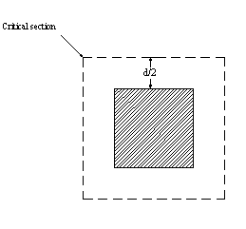
Fig.1-Critical shear perimeter for square loaded areas recommended by ACI

The shear stress $v_{\text{cw}}$and the compressive stress due to the prestressing $f_{\text{pc}}$ produce a principal tensile stress $f_{t}^{'}$ given by $f_{t}^{'}=−\frac{\overset{}{f_{\text{pc}}}}{2}+\sqrt{{\left(\frac{\overset{}{f_{\text{pc}}}}{2}\right)}^{2}+v_{\text{cw}}^{2}}$ (1)
Solving for $v_{\text{cw}}$in equation (1) gives
$v_{\text{cw}}=f_{t}^{'}\sqrt{1+\frac{\overset{}{f_{\text{pc}}}}{f_{t}^{'}}}$ (2)
Letting the tensile strength$f_{t}^{'}=0\text{.}\text{29}\sqrt{f_{c}^{'}}$, the critical shear stress in equation (2) becomes

$v_{\text{cw}}=0\text{.}\text{29}\sqrt{f_{c}^{'}}\sqrt{1+\frac{\overset{}{f_{\text{pc}}}}{0\text{.}\text{29}\sqrt{f_{c}^{'}}}}$ (3)
which may be approximated as
$v_{\text{cw}}=0\text{.}\text{29}\sqrt{f_{c}^{'}}+0\text{.}3\overset{}{f_{\text{pc}}}$ (4)
The following ACI equation for beam shear strength $V_{\text{cw}}$ is then obtained by multiplying the critical web shear stress $v_{\text{cw}}$ in equation (4) by the product of the effective depth (d_{p}) and the width of the web (b_{w}) and adding the vertical component of the prestressing force $\text{Vp}$.

$V_{\text{cw}}=(0\text{.}\text{29λ}\sqrt{f_{c}^{'}}+0\text{.}{\text{3f}}_{\text{pc}})b_{w}d_{p}+V_{p}$ (5)

where $λ=1\text{.}0$ for normal-weight concrete, and lesser for lightweight concrete.

Equation (5) has been modified by ACI [10] to obtain the following expression for the punching shear capacity of prestressed concrete slabs. $v_{\text{cw}}=0\text{.}\text{29}\sqrt{f_{c}^{'}}+0\text{.}3\overset{}{f_{\text{pc}}}$

$V_{c}=\left(β_{ϕ}\sqrt{f_{c}'}+0\text{.}{\text{3f}}_{\text{pc}}\right) b_{o}d+V_{p}$ (6)

where$β_{ϕ}$= the smaller of 0.29 or$0\text{.}\text{083}\left(α_{s} {\text{d/b}}_{o}+1\text{.}5\right)$with$α_{s}=\text{40}$ for an interior slab-column connection.$f_{c}^{'}$is the concrete compressive strength, $d$is the effective depth of the PT slab, $f_{\text{pc}}$ is the average compressive stress due to the pre-stressing force in both directions and $b_{o}$ is the perimeter of the critical section. $V_{p}$is the vertical component of all the prestressing forces crossing the critical section which can be expressed with reference to “Fig. 2” as follows;
$V_{p}=Σ\frac{\text{8Py}}{x^{2}}\left(c+d\right)$ (7)

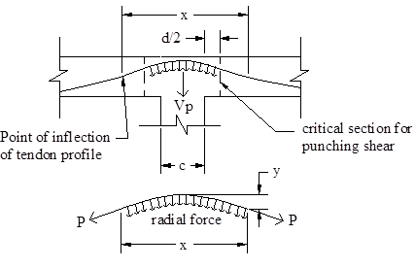

Fig. 2–Tendon profile in the column region

Results from punching shear tests of a number of prestressed concrete slabs with rectangular columns have indicated that equation (4) provides a conservative estimate for the punching shear strength “Fig. 3”.
The current investigation was carried out to verify the ACI predictions for the punching shear capacity of post–tensioned slabs as relatively little data exist on the behavior of the sudden shear at the critical sections.
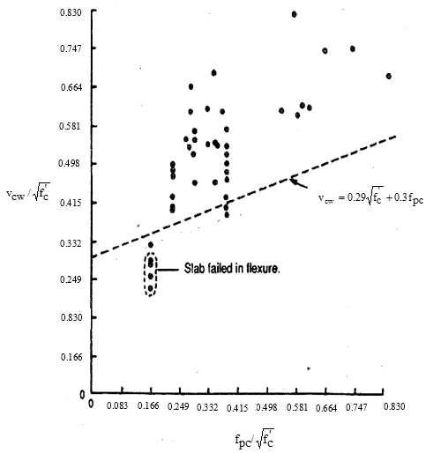
Fig. 3–Shear test data for reinforced concrete slabs plotted with ACI equation [10]

A more rational evaluation of the brittle punching shear was also conducted by considering the distribution of shear and compressive stresses in the critical sections and the variation of the prestressing force with increasing load.

II. RESEARCH SIGNIFICANCE

The primary goal of this research was to conduct an experimental investigation of the brittle punching shear behavior of post tensioned slabs. The slabs were designed to ensure punching shear failure and the tests were conducted by applying a central concentrated load on the post tensioned slabs. An analytical approach is also presented to evaluate the brittle punching shear of PT slabs incorporating the distribution of shear and flexural stresses in the critical sections and the variation of the force in the prestressing tendons.

Experimental Investigation

An experimental investigation was carried out to study the behavior of post-tensioned slabs. The punching shear failure of the PT slabs was ensured by the following approach: the dimensions and thickness of the slab were chosen to yield a punching strength of about 15 Tons (half of the capacity of the loading jack using for the tests) using the ACI equation for punching shear (equation 6). The slab was then analyzed using the “ADAPT FLOOR-PRO” program [7]. The stress contours obtained by applying a 20 Ton load (two third of the capacity of the jack) is shown in “Fig. 4”.
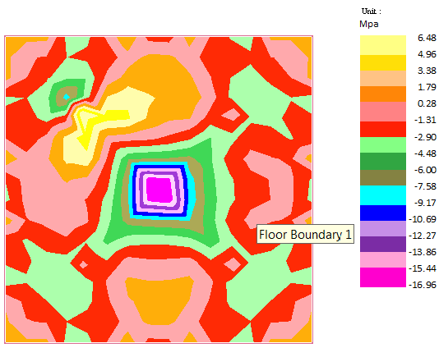

Fig. 4–Principal bottom stress distribution for PT slabs
(Applied Load P=178 kN)

The results indicate that the maximum compressive stress in the concrete at the critical sections is below 60% of the concrete compressive strength, which would ensure a punching shear failure mode of the post tensioned slab. The numbers and the profiles of the prestressing cables were then determined using the “Adapt floor-pro” program and are shown in “Fig. 5”. Two post-tensioned concrete slabs PT-1 and PT-2 with the same dimensions were tested. The test specimens were 1.8m x 1.8m x 100mm. The dimensions of the rectangular column are shown in “Fig. 5”.
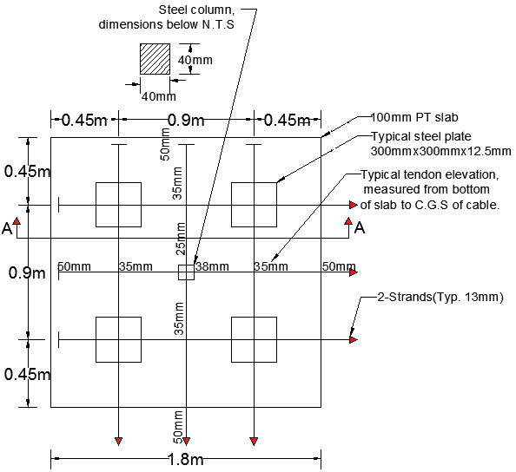
Fig. 5-Post-tensioning tendon layout in PT slabs

Materials
The concrete used for the slabs had a design strength of 26.6 Mpa and was supplied by a local ready-mix plant. The coarse aggregate used was #16 crushed limestone and the water cement ratio was 0.42. PT-1 and PT-2 were cast from one batch of concrete. Five standard cylinders of 150mm radius x 300mm height were cast from each batch and kept in the same environment as the slab. The Compressive strength after 7 days was 18.7Mpa and the strength at the time of testing was 30Mpa.
The prestressing strands used were 12.7 mm diameter seven wire strands conforming to ASTM standard A421, with a specified ultimate strength of 1860 Mpa and an average modulus of elasticity of 197128 Mpa. The tendons were protected with a plastic sheathing to prevent the “cable-concrete” bond and to reduce friction at the time of stressing.

Fabrication of specimens
The edge forms for the slabs were constructed using 20 mm thick, 100 mm high plywood which were braced using 50 mm x 150 mm wood studs. The edge forms were carefully aligned, leveled and nailed to the floor to help prevent movement during casting.
The slabs were cast on the floor over plastic sheets. Prior to casting the slab, the plastic sheets were oiled for ease of removal of the specimens. Chairs were used to ensure that the desired tendon profile was attained. Ready-mix concrete was delivered and pumped to the location of the specimens. The concrete was vibrated and the final slab finish was achieved using steel trowels and wooden floats. A plastic cover was placed over the slab for a 15-day curing period.

Test setup and instrumentation

The specimens were tested in an elevated position using a steel test frame. Application of an upward load allowed for the observation of the punching shear failure on the top surface of the slab. The reaction frame was designed and fabricated of structural steel as shown schematically in “Fig. 6”.
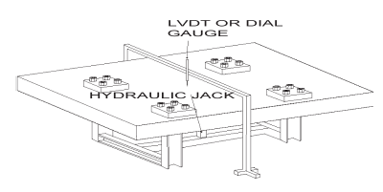
Fig. 6– Schematic diagram of punching shear test set up

The central loading was applied upwards and the concrete slab was held down at four locations which were 900 mm apart. The slab also had a 450 mm overhang on each side. Additional details of the anchorage of the steel slab to the structural frame are shown in “Fig. 7”. A photograph of the post tensioned slab mounted on the testing frame is shown in “Fig. 8”. The tendons were stressed up to 147 kN after the slab was positioned on the test frame.

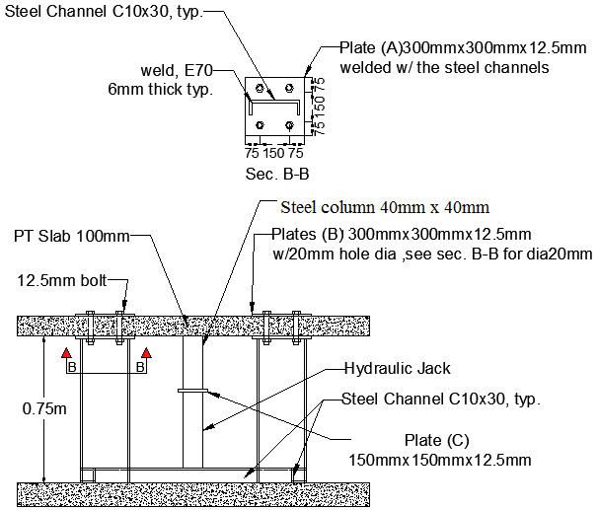

Fig. 7-Steel reaction frame details

The loading was accomplished by using a hydraulic jack. The hydraulic jack was previously calibrated to yield the applied load. A dial gauge was mounted at the center of the slab to measure the displacement of the slab. Load cells were also placed between the edge of the slab and the anchoring mechanism of the prestressing tendons to measure the force in the four central tendons indicated in “Fig. 8”.

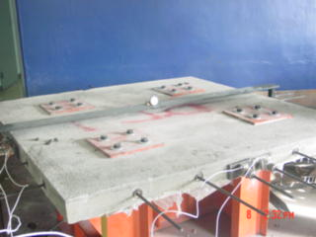

Fig. 8-Photograph of PT slab before test

The strain-gage based load cells were manufactured by “Honeywell Sensotec” and had a capacity of 222kN each.
These load cells were connected to 4 channels digital indicator which displayed the tendon force.

Experimental RESULTS

The tests were carried out by increasing the pressure in the hydraulic jack and recording the central deflection and the tendon forces at each increment of the load. The data for PT-1 and PT-2 are provided in “Table 1” and “Table 2”. The maximum load carried by PT-1 was 112.5 kN with no flexural crack occurred at the top surface. The results presented in “Table 1” indicate that the tendon force increases linearly with the load up to the point of failure.

Table 1-Test results for post-tensioned slab (PT-1)
Load | deflection
Load | deflection | Tendon forces measured by load cells |  |  |  | remarks
(kN) | (mm) | (kN)
0.00 | 0.00 | 77.11 | 79.51 | 104.54 | 107.66
12.00 | 0.07 | 77.11 | 79.52 | 104.55 | 107.67
24.65 | 0.13 | 77.13 | 79.53 | 104.56 | 107.71
34.50 | 0.18 | 77.14 | 79.54 | 104.58 | 107.76
46.70 | 0.28 | 77.17 | 79.56 | 104.60 | 107.88
55.35 | 0.31 | 77.19 | 79.60 | 104.65 | 108.02
68.50 | 0.44 | 77.23 | 79.69 | 104.71 | 108.16
77.25 | 0.50 | 77.28 | 79.77 | 104.76 | 108.30
90.45 | 0.56 | 77.33 | 79.91 | 104.83 | 108.51
98.85 | 0.67 | 77.42 | 80.04 | 104.93 | 108.64
112.50 | 0.85 | 77.60 | 80.11 | 105.04 | 108.88 | SPSF
SPSF: Sudden punching shear failure with no crack indication in slab

The maximum stress in the tendon at failure was 1101 Mpa, the shape of the failure surface was roughly square with a dimension of about 250 mm to 250 mm each side. “Fig 9” shows the failure surface after the removal of the loose concrete.
The central load vs. deflection plots for PT-1 and PT-2 are provided in “Fig. 10”. The load deflection behavior appears to be essentially linear with no change in slope occurring prior to the point of failure, which would ensure a brittle punching shear failure mode of the post tensioned slabs.
SPSF: Sudden punching shear failure with no crack indication in slab
Table 2- Test results for post-tensioned slab (PT-2)
Load | deflection
Load | deflection | Tendon forces measured by load cells |  |  |  | remarks
(kN) | (mm) | (kN)
0.00 | 0.00 | 86.85 | 90.45 | 96.61 | 92.60
11.85 | 0.06 | 86.86 | 90.45 | 96.62 | 92.61
23.35 | 0.14 | 86.87 | 90.46 | 96.63 | 92.63
35.00 | 0.19 | 86.89 | 90.48 | 96.64 | 92.64
46.60 | 0.27 | 86.91 | 90.51 | 96.66 | 92.67
59.85 | 0.37 | 86.95 | 90.55 | 96.69 | 92.73
73.15 | 0.50 | 87.01 | 90.63 | 96.71 | 92.80
90.00 | 0.62 | 87.06 | 90.69 | 96.74 | 92.90
104.75 | 0.76 | 87.12 | 90.73 | 96.79 | 97.42
111.65 | 0.83 | 87.20 | 90.81 | 96.89 | 97.46 | SPSF
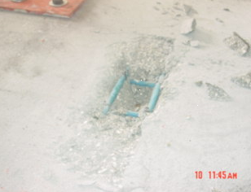

Fig. 9-Sudden punching shear failure of PT-1 after removal of loose concrete

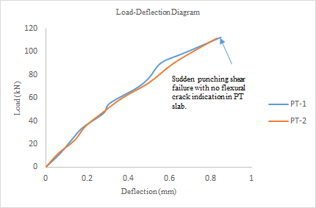

Fig.10-Load-deflection diagram for PT-1 and PT-2

Comparison of test results with the ACI Equation for punching shear strength

The test results are compared with the values obtained from the ACI equation (6) in “Table 3”.

Table 3-Comparison of punching shear test results with ACI Equation

Specimen  designation | Test results | ACI Equation
Specimen  designation | kN | $$f_{\text{pc}}$$  Mpa | $$b_{o}$$  mm | $$V_{p}$$  kN | $$V_{c}$$  kN
PT-1 | 112.5 | 2.96 | 119.4 | 18.24 | 113.8
PT-2 | 111.6 | 2.96 | 119.4 | 18.24 | 113.8

For PT-1&PT-2 the test results were found to be almost equal or slightly not conservative compared with the ACI predictions.
The ACI approach for punching shear is based on the punching shear capacity of a critical section located at a distance d/2 from the column face and includes the major design variables of effective depth, tendon effective force, concrete compressive strength, and the critical perimeter. It does not however account for the distribution of shear and flexural stresses in the critical sections and the variation of the force in the prestressing tendons. The following analysis is presented for evaluation of the brittle punching shear of a PT slab where the distribution of shear and flexural stresses at the critical perimeter are considered.

EVALUATION OF THE BRITTLE PUNCHING SHEAR FAILURE OF PT SLABS

Following the ACI approach, punching shear failure is expected to occur at the critical perimeter which is at a distance d/2 from the effective loaded area “Fig. 1” and would produce four segments for a rectangular column “Fig. 11”. For a given load, the internal stresses in these sections can be obtained using “ADAPT” software.
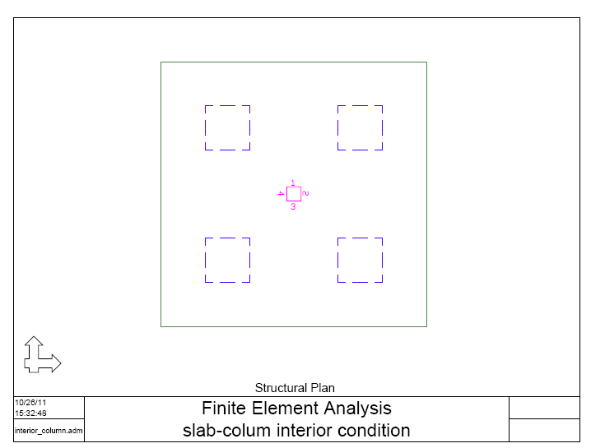
Fig. 11-Design sections for the PT slabs (ADAPT)
The shear stress in any section is produced by a combination of the shear force “V_{c}” and the fraction of the unbalanced moment “M_{u}”, as per ACI 11.12.6. In the current tests the unbalanced moment is negligible and the shear distribution may be considered to be parabolic through the depth of the slab. The flexural stresses can also be considered to vary linearly through the depth and are produced by a combination of the prestressing force and the bending moment.
Flexural cracking is not expected to occur in a particular section if the normal stress f_{t} at the top surface is lower than the modulus of rupture f_{r}. The shear and flexural stress distribution in sections where flexural cracking has not occurred is shown schematically in “Fig 12”.

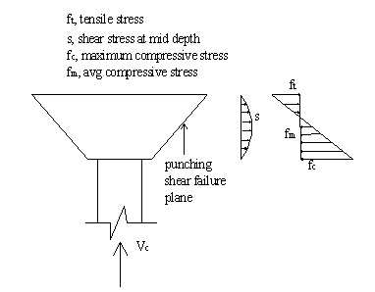
Fig. 12-Stress conditions in sections without flexural cracks

For the uncracked sections, the maximum available shear resistance may be obtained by equating the principal tensile stress at the mid depth of the section to the critical tensile stress of $0\text{.}\text{29}\sqrt{f_{c}^{'}}$. The principal tensile stress at mid depth of the uncracked sections is a combination of the shear stress and the flexural stress $f_{m}$given by
$f_{m}=\frac{f_{c}−f_{t}}{2}$ (8)

When the tensile stress at the top fiber exceeds the modulus of rupture, flexural cracking will occur in which it did not occur in this test.
In this proposed analysis the theoretical brittle punching shear was calculated at the point where the principal tensile stress at the mid depth of the section equal to the critical tensile stress of $0\text{.}\text{29}\sqrt{f_{c}^{'}}$, thus no flexural failure occurred at the top surface of the PT slabs.
For the uncracked sections, the principal tensile stress $f$at the mid-depth of the uncracked portion can be expressed as a function of $f_{m}$ and $s$as
$f=−\frac{f_{m}}{2}+\sqrt{{\left(\frac{f_{m}}{2}\right)}^{2}+s^{2}}$ (10)

Solving equation (10) for the shear stress $s$yields
$s=\sqrt{f(f+f_{m})}$ (11)
(11)
Considering the parabolic nature of the shear distribution, the total punching shear capacity for all the critical sections can be expressed as follows

$V_{c}=\text{2/3} \sum{\left[\sqrt{f(f+f_{m})} L_{i}d_{i}\right]}+V_{p}+V_{I}$ (12)

where the 2/3 factor is based on the assumed parabolic distribution for the shear stresses, indicates the summation over all the critical sections,$L_{i}$ is the length of critical section, $d_{i}$ is the shear depth, in this test$d_{i}$equal to the slab thickness since $f_{t}<f_{r}$ ,$f_{m}$is the average compressive stress, $f$is the critical tensile stress which is taken as $0\text{.}\text{29}\sqrt{f_{c}^{'}}$. $V_{p}$is the vertical component of all the prestressing forces crossing the critical sections. $V_{I}$is the aggregate interlock force which is not accounted for in the present analysis since $f_{t}<f_{r}$, in this case$V_{I}$ should be set to zero.

- Comparison of predictions with experimental results

The “ADAPT FLOOR-PRO” program provides the internal stresses at the critical sections, for instance, the internal stresses at the critical sections for an applied load of 90 kN are listed in “Table 4”. An analysis of the stresses at these sections

Table 4-Internal stresses at the critical sections from

ADAPT for PT slab (Applied Load P=90 kN)

Design section | Top stress | Bottomstress | Average stress "f_{m}" | Un-cracked depth of slab  "d_{i}" | Length  L_{i} | PSL
 | Mpa | Mpa | Mpa | mm | mm | kN
Sec. 1 | 1.35 | -7.72 | 3.18 | 100 | 120 | 22.00
Sec. 2 | 0.65 | -6.16 | 2.76 | 100 | 120 | 21.00
Sec. 3 | 1.48 | -7.85 | 3.18 | 100 | 120 | 22.00
Sec. 4 | 0.56 | -6.08 | 2.76 | 100 | 120 | 21.00
Punching shear resistance of concrete over the entire critical section (including V_{p}) =104.2 KN, where V_{p}=18.20 kN
PSL=Punching shear load using equation (12)

indicates that the tensile stresses at the top surface did not exceed the modulus of rupture of$f_{r}=0\text{.}\text{625}\sqrt{f_{c}^{'}}=3\text{.}\text{42} \text{Mpa}$, these sections may thus be considered uncracked. The available punching shear resistance for this applied load may be evaluated using equation (12). As the available punching shear strength at this stage is of 104.7 kN, it is higher than the applied load, and punching shear failure is not expected to occur at this load.
This procedure may be repeated for additional loads to obtain the available punching shear capacity for the critical sections equal to the applied load. The punching shear strength evaluation for an applied load of 105 kN is shown in “Table 5”.
As the applied load increases 90kN to 105kN, the average stress$f_{m}$becomes constant at the critical sections. “Table 3 and 4”.
The assumed location for the critical sections are taken in this proposed procedure at distance d/2 from the effective loaded area “Fig. 1” as the ACI predictions, however other trial critical sections have been investigated and figured out that the available punching shear capacity for the trial critical sections not equal to the applied load.

Table 5- Brittle punching shear value of PT slab

(Applied load P= 105kN)

Design section | Top stress | Bottomstress | Avg. stress "f_{mi}" | Un-cracked depth of slab  "d_{i}" | Length  L_{i} | PSL
 | Mpa | Mpa | Mpa | mm | mm | KN
Sec. 1 | 3.12 | -9.49 | 3.18 | 100 | 120 | 22.00
Sec. 2 | 2.46 | -7.97 | 2.76 | 100 | 120 | 21.00
Sec. 3 | 3.29 | -9.66 | 3.18 | 100 | 120 | 22.00
Sec. 4 | 2.34 | -7.86 | 2.76 | 100 | 120 | 21.00
Punching shear resistance of concrete over the entire critical section (including V_{p})=104.7 kN, where V_{p}=18.7 kN
PSL=Punching shear load using equation (12)

Using equation (12), a punching shear resistance of 104.7 kN is obtained corresponding to this applied load which is nearly equal to the applied load.
The punching shear resistance predicted using the proposed procedure is shown plotted with the applied load for PT-1 and PT2 in “Fig 13”. Punching shear failure is expected to occur when the applied load reaches the available punching shear capacity which occurs at 104.7 kN. The average punching shear test results for PT-1and PT2 is 112.1 kN which is about 7% higher than the predicted capacity. For PT1 and PT-2 the ACI method predicted a punching shear strength of 113.8 kN which is about 2% higher than the test results.

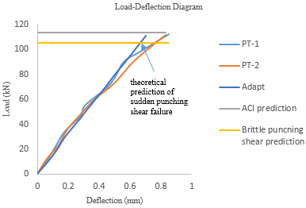
Fig. 13- Analytical and experimental load deflection curves for PT slabs

FURTHER RESEARCH

The analysis outlined in the paper was conducted by evaluating the brittle punching shear in PT slabs considering the uncracking behavior at the critical sections but the analysis did not address the cracking behavior at the critical sections which did not occur in this test. More investigation is needed for the proposed analysis to consider the cracking at the critical sections and to apply the finite element analysis using an element which exhibits cracking behavior to get more refined results and a better estimation for the load-deflection diagram. Research is also needed to check the validity of the assumed location of the critical sections and to quantify the effects of the aggregate interlock when considering the cracking behavior.

CONCLUSIONS

Results of a sudden punching shear of post tensioned slabs were presented in this paper. The tests demonstrated that the PT slabs failed suddenly in punching shear with no indication of flexural cracks. The load-deflection diagram at failure stage was linear. The test results for PT slabs were 2% lower than those predicted by the ACI equations however they were 7% higher than predicted by the proposed analysis. In order to obtain more refined punching shear predictions, the punching shear capacity at service stage may be checked as the ACI predictions was slightly not conservative compared with the test results.

IV. ACKNOWLEDGMENTS

The authors wish to express their gratitude and sincere appreciation to PTE Strand Co., Inc. for letting the tests be conducted at their facilities and for providing the test material and assistance in casting, stressing the tendons and conducting the tests. The authors would also like to thank Steel Fabricators Inc. of Fort Lauderdale for fabricating and providing the steel test frame for this research.

NOTATION

$\text{bo}$= perimeter of critical shear section
$b_{w}$= width of web of prestressed beam
$d$ = distance from the extreme compression fiber to the centroid of tension reinforcement
$d_{p}$= distance from extreme compression fiber to centroid of prestressed reinforcement
$d_{i}$= the shear depth measured from extreme compression face to the threshold of cracking
$f$= principal tensile stress
$f_{{}_{c}}^{'}$= concrete compressive strength
$f_{m}$= average compressive stress
$f_{\text{pc}}$= the average compressive stress due to prestressing force
$f_{r}$= concrete modulus of rupture
$f_{c}$= concrete compressive stress
$L_{i}$= length of the critical section
$M_{u}$= unbalanced moment about the centroid of the entire critical section
$s$= shear stress over the critical section
$V_{p}$= sum of the vertical components of effective prestressing
force for tendons crossing the critical section
$V_{c}$= punching shear load carried by concrete over the entire critical section
$v_{\text{cw}}$= nominal shear stress
$V_{\text{cw}}$= nominal shear strength provided by the concrete when diagonal cracking results from
principal tensile stress in web
x= distance between the inflection points of tendon over the column region
y= distance from the tendon inflection point to the tendon high point
REFERENCES

1. ASCE-ACI Task Committee 426. “The Shear Strength of Reinforced Concrete Members-
Slabs,” Journal of the Structural Division, Vol. 100, No. ST8, August, 1974, pp. 1543-1591.

2. ACI Committee 318, “Building Code Requirements for Reinforced Concrete (ACI 318-71),” American Concrete Institute, Mich., 1971, also yearly supplements to ACI 318-71.

3. Scordelis, A.C., T.Y. Lin and H.R. May, “Shearing Strength of Prestressed Lift Slabs,” ACI Journal, Vol. 55, No. 4, October, 1958, pp. 485-506.

4. Grow, J.B. and M.D Vanderbilt, “A study of the Shearing Strength of Lightweight Prestressed Concrete Flat Plates,” PCI Journal, Vol. 12, No. 4, August, 1967, pp. 18-28.

5. Gerber, L.L. and N.H. Burns, “Ultimate Strength Tests of Post-Tensioned Flat Plates with Unbonded Tendons,” ACI Journal, Vol. 71, No. 2, February, 1974, pp.61-71.

6. Hemakom, R., “ Strength and Behavior of Post-tensioned Flat Plates with Unbonded tendons,” Unpublished PhD Dissertation, the University of Texas at Austin, December, 1975.

7. Aalami, B. O., Adapt-Builder Ex (2006), “FEM Software for Analysis and Design of Post-Tensioned Floor Systems,” ADAPT Corporation, Redwood City, California.

8. ACI-ASCE Committee 423, “Tentative Recommendations for Prestressed Concrete Flat Plates,” ACI Journal, Vol. 71, No. 2, February, 1974, pp. 61-71.

9. Hawkins, N.M. and N. Trongtham, “Moment Transfer between Unbonded Post-Tensioned Prestressed Concrete Slabs and Columns,” A Progress Report to the Post-Tensioning Institute and the Reinforced Concrete Council on Project No. 39, The University of Washington, November, 1976.

10. ACI Committee 318, “Building Code Requirements for Reinforced Concrete (ACI 318-05),” American Concrete Institute, Mich., December 2004.

11. Smith, S.W and N,H. Burns, “Post-Tensioned Flat Plate to Column Connection Behavior,” PCI Journal, Vol. 19, No. 3, May-June, 1974, pp. 74-91.

12. Nawy, E. G. “Prestressed Concrete-A Fundamental Approach, 3rd Ed.”, Upper Saddle River, N.J; Prentice Hall, 2000, pp.189 and pp.234.

