**Low-Cost Scale Production of Structural Carbon - A Challenge to Chemical Engineers**

M. Razi Nalim

Indiana University - Purdue University, Indianapolis

Abstract

**Versatility of Carbon**

Of the forms of elemental carbon found near the surface of the Earth, coal appears to be most abundant. But carbon in other essentially elemental forms has substantially different properties and thus costs much more than coal. The table below compares the cost of other forms of elemental carbon with coal:

|  |  |  |
| --- | --- | --- |
| Elemental carbon form | Approximate mass procurable for US $10 | Approximate ratio of price, relative to coal |
| Coal | 1 Mg (tonne) | 100 |
| Carbon black | 10 kg | 102 |
| Activated charcoal | 1 kg | 103 |
| Carbon fiber | 1 kg | 103 |
| Graphene | 1 g | 106 |
| Carbon nanotubes | 0.1 g | 107 |
| Diamond ½ carat | 1 mg | 109 |

Carbon is a chemically very versatile atom that is the basis of life, along with water. We have only begun to understand its potential as a material for other uses. There is a large volume potential market for carbon fiber to create structural material that can replace steel, aluminum, wood, and plastics. The more costly forms, such as graphene, nanotubes, and diamond are certainly highly valuable, and may represent large markets by value but carbon fiber and resulting yarns and textiles are likely to represent substantial markets by mass. Structural uses of carbon may have the greatest potential to supplant combustion uses that add CO2 to the Earth’s atmosphere.

**Carbon fiber**

Carbon fibers can be made to about 5–10 micrometres in diameter. Much thinner than a human hair (see figure below), they are composed mostly of carbon atoms, and have crystals aligned with long axis.

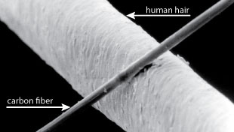

Carbon fibers have high stiffness, high tensile strength, low weight, high chemical resistance, high temperature tolerance, and low thermal expansion. Carbon fiber has up to 10 times the stiffness in tension, relative to steel, but is much lighter and corrosion resistant (with proper resins). This makes them useful in aerospace, civil engineering, military, motorsports, and competition sports. However, they are relatively expensive when compared with other fibers or structural materials, such as steel, aluminum, glass or plastics. Price is over $10/kg, too costly for many potential applications. Even a moderate reduction in cost could open up large markets.

Carbon fibers are made from precursors that are various organic polymers:

1. polyacrylonitrile (PAN), made from petroleum, the most common
2. rayon, from regenerated wood cellulose
3. petroleum pitch

The best quality and largest quantities of fibers are made from petroleum-derived PAN. Alternate approaches may use rayon or pitch as precursors, or may use PAN derived from other sources such as biomass.

Carbon fiber yarn is made by twisting together several thousand fibers, and may be combined with epoxy. The typical method of manufacture of carbon fiber yarn and fabric from PAN consists of the following steps:

* Mixing PAN with another plastic (methyl acrylate or methyl methacrylate) and reacted with catalysis to form a PAN plastic
* Spinning hot plastic into fibers by cooling in a bath or quench chamber and solidifying, with desired internal structure forming through chemical changes or evaporation of solvents.
* Washing and stretching to desired diameter, aligning molecules to prepare for carbon crystallization
* Stabilizing by heating in air and other gases at 200-300 oC, where oxygen helps rearrange bonding pattern.
* Carbonizing by heating at 1000-3000 oC without oxygen, to form tightly bonded aligned crystals.
* Surface oxidizing with air/CO2/O3/HNO3/NaClO to improve bonding with composites or epoxies, while avoiding surface defects.
* Coating/sizing to protect from damage
* Winding into bobbins, spinning into yarns, knitting into fabrics.

**Demand for carbon fiber**

The demand for carbon fibers has been growing rapidly, especially after their introduction around 2005 into the newest commercial aircraft as structural materials, as illustrated below (Warren).

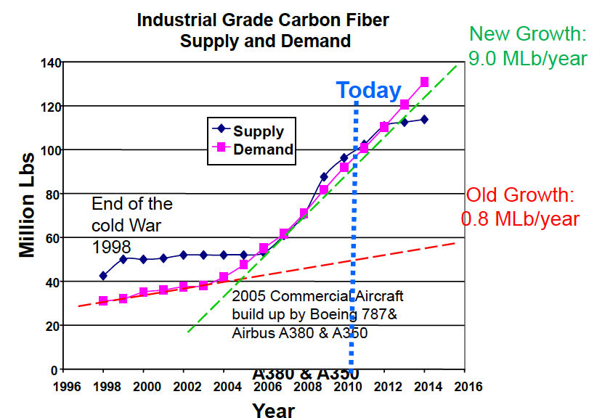

The US Department of Energy has goals for the development of composite materials for wind turbine blades of higher strength and stiffness than currently affordable. Carbon fibers could meet or exceed such goals, if the cost can be reduced. Other applications for structural materials could likewise benefit.

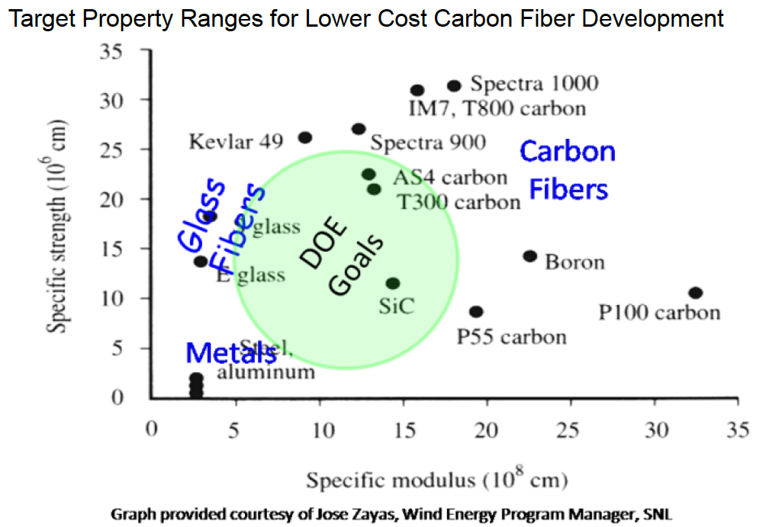

There are several major research groups and facilities around the world focused on carbon fiber R&D. These include the Oak Ridge National Laboratory (ORNL) in the US and Kyushu University Institute for Materials Chemistry and Engineering in Japan. ORNL has established a Carbon Fiber Technology Center (CFTF) with a highly instrumented, highly flexible carbon fiber line. It accommodates “any precursor in any format” with a melt-spun fiber line to produce up to 25 tonnes/year. It is intended to demonstrate technology scalability, train and educate workers, and work in partnerships with industry.

**Biomass to Carbon Fiber**

There are multiple approaches to obtain fiber from biomass. Biomass tar contains phenol-group compounds that can be polymerized into a thermo-setting resin as a precursor. Carbon fibers of 10-20 micrometer have been prepared with tensile strength and tensile modulus comparable to commercial isotropic carbon fibers (Qiao et al, Yoon @ Kyushu). However, the variety of biomass polymers would require carefully tailored approaches that can adapt to different sources of biomass, such as sisal, bamboo, hemp, grain crop residues, and other cellulosic fibers.

More recently, there has been much progress in the use of lignin as a feedstock with natural polymeric compounds. (Baker & Rials, 2013; Compere et al). Based on low-cost, high-volume, carbon yield, and melt-spinnability, Kraft lignin blends appear to be an excellent alternative carbon fiber feedstock. Current studies have established the ability to melt-spin small tows of 10-20 micron diameter fibers.

Other approaches focus on production of PAN from biomass, so that the existing processes for conversion of PAN to carbon fiber can be used.

**Coal to Carbon Fiber**

In the past, there have been proposals to investigate the manufacture of carbon fiber from coal, particular at times when the price of petroleum was high. These efforts have not been sustained, but may be worth considering in the context of carbon abatement. One approach to creating highly graphitic carbon fibers from pulverized coal fines is through vapor-grown carbon-fiber (Burton et al). However, a more efficient conversion process could take advantage of the natural properties of various coals. (Derbyshire). It has been shown that continuous filaments of isotropic carbon fibers can be produced from coal liquefaction products.

**Natural Gas to Carbon Fiber**

The relative abundance and low cost of natural gas has revived an interest in using it as a feedstock for production of both carbon fiber and hydrogen fuel. Whether this abundance can be supported (Gold, 1989) by particular theories of the origin of natural gas is debatable. However, the current progress in shale and tight gas extraction is an opportunity to pursue technology that can provide both energy and materials while limiting emissions.

**Summary**

This presentation will review the opportunities to expand the range of feedstocks that can be used for production of carbon fiber in quantities that may become comparable to other tensile structural materials such as steel. The creation of high-value products from elemental carbon may disrupt the reliance on energy from combustion of carbon and emissions of carbon dioxide on a scale that speeds the transition to carbon-neutral energy, including renewable energy. Selective use of only the hydrogen content of petroleum and natural gas as fuel, whether by combustion or electrochemical cells, or for other purposes, may be a by product of this trend.

**References**

Baker, D. A. and Rials, T. G. (2013), Recent advances in low-cost carbon fiber manufacture from lignin. J. Appl. Polym. Sci., 130: 713–728. doi:10.1002/app.39273

WM Qiao, M Huda, S-H Yoon, Y Korai, I Mochida, H Hayashi, K Kawamoto, “Development of carbon fibers from biomass tars,”

D. Burton, M. Lake, and R. Alig (Applied Sciences, Inc.), “Production Of Vapor Grown Carbon Fiber With Coal Fines Without SO2, Emissions,”

Thomas Gold, “Natural Gas May Hold Key in Global-Warming Era,” New York Times, 1989.

Frank Derbyshire, “Carbon Materials From Coal,” Center for Applied Energy Research, University of Kentucky.

C. David Warren - ORNL, “Low Cost Carbon Fiber Overview”, presentation, 2010.

<http://www1.eere.energy.gov/vehiclesandfuels/pdfs/merit_review_2010/lightweight_materials/lm002_warren_2010_o.pdf>